Supplementary Information:

Custom CRISPR—Cas9 PAM variants via scalable engineering and machine learning
Rachel A. Silverstein¹⁻³, Nahye Kim^{2-4,17}, Ann-Sophie Kroell^{2,3,5,17}, Russell T. Walton^{2,3}, Justin Delano⁶⁻⁹, Rossano M. Butcher^{10,11}, Martin Pacesa¹², Blaire K. Smith^{2,3}, Kathleen A. Christie²⁻⁴, Leillani L. Ha^{2,3},Ronald J. Meis¹³, Aaron B. Clark¹³, Aviv D. Spinner^{1,15}, Cicera R. Lazzarotto¹⁴, Yichao Li¹⁴, Azusa Matsubara¹⁴, Elizabeth O. Urbina¹⁴, Gary A. Dahl¹³, Bruno E. Correia¹², Debora S. Marks^{9,15}, Shengdar Q. Tsai¹⁴, Luca Pinello^{4,7-9}, Suk See De Ravin¹⁶, Qin Liu^{10,11}, Benjamin P. Kleinstiver²⁻⁴

- PhD Program in Biological and Biomedical Sciences, Harvard Medical School, Boston, MA, USA
- Center for Genomic Medicine, Massachusetts General Hospital, Boston, MA, USA
- Department of Pathology, Massachusetts General Hospital, Boston, MA, USA
- Department of Pathology, Harvard Medical School, Boston, MA, USA
- Institute of Pharmacy and Molecular Biotechnology (IPMB), Faculty of Engineering Sciences, Heidelberg University, Heidelberg, Germany
- Department of Biomedical Informatics, Harvard Medical School, Boston, MA, USA
- Molecular Pathology Unit, Massachusetts General Hospital, Charlestown, MA, USA
- Krantz Family Center for Cancer Research, Massachusetts General Hospital Charlestown, MA, USA
- Broad Institute of Harvard and MIT, Cambridge, MA, USA
- Ocular Genomics Institute, Massachusetts Eye and Ear, Boston, MA, USA
- Department of Ophthalmology, Harvard Medical School, Boston, MA, USA
- Laboratory of Protein Design and Immunoengineering, École Polytechnique Fédérale de Lausanne and Swiss Institute of Bioinformatics; Lausanne, Switzerland
- CELLSCRIPTTM, Madison, WI, USA
- Department of Hematology, St. Jude Children’s Research Hospital, Memphis, TN, USA
- Department of Systems Biology, Harvard Medical School, Boston, MA, USA
- Laboratory of Clinical Immunology and Microbiology, National Institute of Allergy and Infectious Diseases, National Institutes of Health, Bethesda, MD, USA
- Contributed equally.
Correspondence to: Benjamin P. Kleinstiver bkleinstiver@mgh.harvard.edu

Supplementary Information – Table of Contents

Supplementary Tables
Supplementary Table 1: HT-PAMDA data
Supplementary Table 2: PAMmla predicted enzymes
Supplementary Table 3: Oligonucleotides
Supplementary Table 4: Plasmids
Supplementary Table 5: sgRNA target sites
Supplementary Table 6: GUIDE-seq-2 results
Supplementary Table 7: Source data
Note: All Supplementary Tables are attached as separate .xlsx files.

Supplementary Notes
Supplementary Note 1: Necessity of PAM positioning precision genome editing p.3
Supplementary Note 2: Previous engineered SpCas9 PAM variant enzymes. p.3
Supplementary Note 3: Design, cloning, and testing of the SpCas9 PI domain libraries p.4
Supplementary Note 4: Bacterial-based positive selection assays p.5
Supplementary Note 5: Definition of inactive enzymes via HT-PAMDA p.5
Supplementary Note 6: Structural modeling of PAMmla predicted SpCas9 variant enzymes p.6
Supplementary Note 7: Base editing of the sickle cell HBB E7V mutation p.7
Supplementary Note 8: Extended analysis of GUIDE-seq-2 results p.7
Supplementary Note 9: In silico directed evolution of SpCas9 PAM variant enzymes p.7
Supplementary Note 10: Evaluation of alternate Cas9 ortholog nucleases for RHO P23H p.9
Supplementary Note 11: Structure-function analysis for allele-selective NGTG enzymes p.9
Supplementary Note 12: Activity and specificity of PAMmla-derived and PAM-relaxed enzymes p.10
Supplementary Note 13: Previous ML-based approaches to engineer CRISPR-Cas proteins p.11

Supplementary Figures
Supplementary Figure 1: Workflow for a whole-ORF sequencing approach p.12
Supplementary Figure 2: PAM profiles for SpCas9 enzymes derived from bacterial selections and
random enzymes from the SpCas9(6AA) library p.13
Supplementary Figure 3: Correlation between preferred PAM and sequence selected against p.17
Supplementary Figure 4: PAM preferences of SpCas9 enzymes with relaxed NGN PAM requirements p.18
Supplementary Figure 5: Necessity of R1335 for NGG PAM recognition p.19
Supplementary Figure 6: Rational design of consensus SpCas9 enzymes resulting from the 16x
bacterial selections using NGNN PAMs p.20
Supplementary Figure 7: PAMmla predictions for 64 million Cas9 variants p.21
Supplementary Figure 8: PAM profiles and sorting criteria for PAMmla predicted SpCas9 enzymes p.22
Supplementary Figure 9: Most efficiently targeted PAMs for top PAMmla predicted enzymes p.25
Supplementary Figure 10: Ranking of bacterial selection-derived enzymes amongst the SpCas9(6AA)
library p.26
Supplementary Figure 11: Experimental and predicted PAM profiles for engineered SpCas9 enzymes p.27
Supplementary Figure 12: Genome editing in human cells with PAMmla predicted enzymes p.28
Supplementary Figure 13: A-to-G base editing with PAMmla predicted enzymes p.30
Supplementary Figure 14: C-to-T base editing with PAMmla predicted enzymes p.31
Supplementary Figure 15: Creation of a sickle cell HBB E7V cell line and base editing with
ML-derived PAM variants p.32
Supplementary Figure 16: in silico directed evolution of PAM-selective SpCas9 enzymes p.34
Supplementary Figure 17: Prime editing to create a RHO P23H cell line p.36
Supplementary Figure 18: Assessment of Cas9 orthologs for allele-specific targeting of RHO P23H p.38
Supplementary Figure 19: Comparison of HT-PAMDA datasets with evolutionary model predictions p.39

Supplementary References p.40

Supplementary Notes

Supplementary Note 1: Necessity of PAM positioning precision genome editing.
The ability to precisely edit the genome is dependent on having sufficiently versatile enzymes capable of recognizing nearly any target site¹ (e.g. for base editing, prime editing, allele-selective editing, molecular approaches, etc.). Base editing is particularly sensitive to the placement of Cas9 on DNA with single base pair precision. Base editors have an activity window (edit window) which is defined as the range of single stranded DNA bases which are accessible for deamination when Cas9 forms a R-loop at the target site^{2–5}. The base editor edit window varies depending on the Cas enzyme, deaminase, and base editor construct, but for the majority of SpCas9-based base editors, most efficient editing typically occurs at approximately positions 5-8 in the protospacer (counting from the PAM-distal end)² . To highlight the challenge of protospacer-adjacent motif (PAM) availability in the context of base editing, we analyzed the genomic contexts of all 47,159 pathogenic and likely pathogenic SNPs annotated on ClinVar⁶ (accessed August 2021) for available NGG PAMs which placed the pathogenic point mutant within the optimal edit window at positions 5-8 of the protospacer (Extended Data Fig. 1a). We found that approximately one quarter of annotated SNPs which could be theoretically reverted with either a cytosine or adenine base editor had an appropriately positioned NGG PAM to place the optimal edit window of the base editor over the target base. The total number of base-editable SNPs is likely even lower in practice due to the additional constraint of positioning the editor in such a way as to avoid harmful bystander edits or for the avoidance of off-target edits.

Supplementary Note 2: Previous engineered Cas9 PAM variant enzymes.
Previous efforts have sought to engineer the PAM specificity of SpCas9 and other Cas enzymes^{7–11}. SpCas9 PAM engineering has sought to alter the PAM requirement (modifying the PAM preference away from NGG ; Extended Data Figs. 1b,c), or to relax the PAM requirement to enable access to new PAMs while retaining some activity against NGG (Extended Data Fig. 1d). Relatively few PAM-altered SpCas9- enzyme variants have been developed, two examples being VRER and VRQR which alter the specificity away from NGG to target NGCG or NGAG/NGNG PAMs, respectively (Extended Data Fig. 1c). A much more common engineering trajectory is the relaxation of the PAM requirement towards more generalist enzymes. Most engineered SpCas9 PAM variants harbor a relaxed PAM requirement, including SpCas9-NG (NGN PAM)¹², xCas9 (reported originally as NGN¹³, later shown to target NGG and NGNC^{14,15}), SpG and SpRY (NGN and NRN>NYN PAMs, respectively)¹⁵, and the SpCas9-NRRH, -NRCH, and -NRTH enzymes¹⁶ (Extended Data Fig. 1d). Both selective and relaxed enzyme variants have advantages and disadvantages. Relaxed variants allow target sites with a diversity of PAMs to be targeted with a single enzyme, making them broadly useful for research applications or uses involving multiplexed editing, necessitating compatibility with a wide range of PAMs. However, enzymes with expanded PAM requirements typically exhibit increased off-target editing due to a larger fraction of the genome being accessible compared to wild-type (WT) SpCas9^{15,17,18}. In the context of base editors, protracted genome searching by PAM-relaxed editors can also lead to increased guide-independent off-target deamination¹⁹. Additionally, since these enzymes are not specialized for a specific PAM of interest, they tend have sub-optimal activity on many PAMs that are within their theoretical targeting range (likely due to genome search kinetics or enzymatic attenuation resulting from engineering)¹⁸.

Supplementary Note 3: Design, cloning, and testing of the SpCas9 PI domain libraries.
To construct a library of enzymes as input for directed evolution to select for SpCas9 enzymes capable of recognizing alternate PAMs, we identified 6 amino acid positions (D1135, S1135, G1218, E1219, R1335, and T1337) within the PI domain of SpCas9 for saturation mutagenesis (Extended Data Fig. 2a). Within the context of a wild-type SpCas9:DNA:single-guide RNA (sgRNA) tertiary complex, R1335 forms a base specific contact with the guanine nucleotide in the third position of the PAM²⁰. However, altering this amino acid alone is insufficient to change PAM specificity, and mutation of this residue without other nearby substitutions largely abrogates nuclease activity^{21,22}. For the previously described SpCas9 PAM variant enzymes SPCas9-VRER (with D1135V, G1218R, R1335E, and T1337R substitutions)²¹, SpCas9-VRQR (D1135V, G1218R, R1335Q, and T1337R)^{21,23}, and SpG (D1135L, S1136W, G1218K, E1219Q, R1335Q, and T1337R)¹⁵, additional mutations were necessary at residue positions D1135, S1136, G1218, E1219, and T1337. These amino acid side chains do not directly contact the PAM DNA bases, but substitutions were necessary to alter PAM recognition^{15,21,22,24}. Mutations at these positions are thought to be involved in altering the conformation of the PAM DNA backbone, allowing access to DNA bases by amino acids with side chains shorter than that of the wild-type arginine residue, and/or by creating new stabilizing interactions with the DNA backbone to compensate for weaker base-specific PAM interactions^{22,24}. The T1337R mutation has been previously shown to enable a novel base-specific contact at the fourth position of the PAM, an interaction that is not typically observed wild-type SpCas9 and an NGG PAM^{21,22,24}. We therefore included this position in our SpCas9(6AA) library to explore the potential of expanding the PAM from the canonical 3 nts to 4 nts, potentially imparting additional specificity.
We cloned the SpCas9(6AA) saturation mutagenesis library by first constructing an SpCas9 coding sequence harboring three IIS restriction enzyme cassettes located at the D1135/S1136, G1218/E1219, and R1335/T1337 positions of SpCas9. The entry vector was then utilized in three sequential cloning steps involving restriction digests and subsequent ligations of oligonucleotide libraries harboring NNS codons. This process could be expedited using newer molecular approaches, including SpRYgests²⁵ for digesting the plasmid backbone followed by isothermal assembly²⁶.
The R1333 residue, which forms a base specific contact with the guanine nucleotide in the second position of the PAM²⁰, was not included in our SpCas9(6AA) library despite structural evidence of its importance for PAM interaction. Since substitutions of this residue likely also require additional compensatory mutations of nearby amino acids to change the preference for G at the second position of the PAM (similar to D1135, S1135, G1218, E1219, and T1337 being necessary to support R1335 substitutions that modify the 3rd/4th positions of the PAM), we envisioned that a separate library would be necessary to efficiently access PAMs with modified second position nt preferences. Performing bacterial positive selections with our SpCas9(6AA) library on PAM substrates with A, C, or T at the second position of the PAM failed to produce viable enzymes with PAMs altered at the second nucleotide, supporting this hypothesis (Supplementary Fig. 2c). We also explored the possibility of mutating R1333 residue in addition to the 6 residues included in SpCas9(6AA) library to create a SpCas9(7AA) library with the hope of altering the second position of the PAM. However, bacterial selections with the SpCas9(7AA) library on NAN, NCN, and NTN PAMs again failed to yield enzymes with specificity altered at the second position, indicating that additional mutations of other amino acids near the second position of the PAM are likely necessary to support recognition of non-NGNN PAMs. Thus, in the current study, we focused our efforts on altering the third and fourth positions of the PAM.

Supplementary Note 4: Bacterial-based positive selection assays.
The SpCas9(6AA) library was subjected to a set of 16 bacterial positive selection assays to isolate enzyme variants with non-canonical PAM specificities similar to as previously described^{21,27}. Selections were performed using a plasmid expressing the SpCas9(6AA) library and sgRNA from separate T7 promoters. The SpCas9(6AA) library plasmid also encodes a chloramphenicol resistance cassette. The library plasmid was transformed into BW25141-𝜆DE3 E. coli²⁷ (which T7 polymerase from an integrated 𝜆DE3 prophage) bearing one of sixteen selection plasmids. Selection plasmids contain an arabinose-inducible ccdB toxin and a sgRNA target site containing a protospacer and PAM of interest. The transformed E. coli were plated on selective media containing chloramphenicol and arabinose. Surviving colonies presumably contained an SpCas9(6AA) library member capable of cleaving the target site encoding the PAM of interest (Extended Data Fig. 2b). These selections were performed 16 times with E. coli strains containing each of the 16 NGNN PAMs varying at nucleotides 3 and 4. Plasmid DNA was isolated from 13-60 colonies from each selection (Extended Data Fig. 2c) and sequenced to determine the identity of the surviving SpCas9 variants. Sequencing results of the 16 selection assays revealed differentially enriched amino acids compared to the non-selected library at the 6AA positions (Extended Data Figs. 2c,d). The most commonly observed substitutions across selections were T1337R (associated with selections containing G at the 4th position of the PAM), R1335E (associated with selections containing C at the third position of the PAM), D1135L, and S1136W (both associated with various different selections). Beyond this, it was difficult to discern strong patterns in amino acid enrichment, although it is known that the amino acids identity at each of the 6 randomized positions are important for specifying PAM preference in previously engineered PAM-altered variants^{12,15,21}. Thus, determining rules for rational engineering of improved PAM-altering variants based on this dataset was challenging.
To characterize the PAM profiles of enzymes that survived the bacterial selection via HT-PAMDA, we transplanted the PAM-interacting (PI) domain sequence of SpCas9(6AA) constructs into a human SpCas9 expression plasmid that co-translationally expresses EGFP.

Supplementary Note 5: Definition of inactive enzymes via HT-PAMDA.
Our hypothesis that slow ks are due to random noise and not experimentally reproducible weak enzyme activity is supported by the fact that the enzymes we categorized as “inactive” by this criterion have no correlation between HT-PAMDA experimental replicates using different spacer target sites (Pearson’s r = -0.1-0.1), whereas active variants generally have robust Pearson’s correlations of 0.7-0.9 between replicates (Extended Data Fig. 3h). We assessed whether our ML model was overfit to experimental noise by measuring correlation between predictions and true ks for the inactive enzymes within the test set. The model did not have predictive power (Pearson’s r = 0.12) for the random noise in the PAM profiles of inactive enzymes (Extended Data Fig. 3i). Thus, we conclude that for enzymes with low measured activity where the model produces strong correlations (for example the hamming distance = 4 subset) these predictions are likely meaningful and not an artifact of over-fitting.

Supplementary Note 6: Structural modeling of PAMmla predicted SpCas9 variant enzymes
To investigate the potential functions of PAMmla predicted alterations to SpCas9, we modeled a subset of amino acid substitutions on the structures of SpCas9-VRER²⁸ and SpG¹⁸ (Extended Data Fig. 5) and analyzed the relative importance of different mutations on PAMmla predictions for each PAM using SHapely Additive exPlanations (SHAP) analysis²⁹ (Extended Data Fig. 4). Mutations can be broadly divided into three categories, including those that alter nucleotide bias at the 3rd position of the PAM (Extended Data Figs. 5a-c), that alter nucleotide bias at the 4th position of the PAM (Extended Data Figs. 5d-f), and that result in general modification of PAM recognition by base-independent alterations (Extended Data Figs. 5g-i).
In the first category, an E1219Y substitution can interact with the amino group of bases at the 3rd position of the PAM, facilitating cytosine recognition (Extended Data Fig. 5a). Additionally, R1335Q or R1335E can enable major groove readout of a C-G base pair (Extended Data Fig. 5b). R1335M and E1219C/I/W (or other substitutions to hydrophobic amino acids) enable 3rd position T readout by forming a hydrophobic pocket compatible with the thymine methyl group (Extended Data Fig. 5c). SHAP values also suggest that S1136R may be important for readout of NGT PAMs (Extended Data Fig. 4), but further structural investigations are required.
In the second category, T1337R can read out G at the 4th position of the PAM, as previously observed in SpCas9-VRER²⁸, SpG, and SpRY¹⁸ (Extended Data Fig. 5d). The T1337K substitution may facilitate interaction with the -OH group of 4th position nucleotides enabling readout of G or T (Extended Data Fig. 5e). T1337C and R1337L or other hydrophobic amino acid substitutions allow for 4th position T readout through hydrophobic interactions (Extended Data Fig. 5f). T1337S may result in 4th position C recognition through amino group readout, however more substantial repositioning of the PAM DNA would be required. There are many additional mutations indicated to be important based on SHAP values (Extended Data Fig. 4) for which structural studies to investigate the possibility of interplay between multiple mutations to reposition either the PAM DNA backbone or PI domain are needed.
In the third category, D1135 mutations to L, K, M, or A resulted in disruption of R1114 coordination, allowing R1114 to form novel nonspecific contacts with the non-target strand (NTS) backbone (Extended Data Fig. 5g). G1218 substitution to positive K, R, or H side chains may form additional nonspecific contacts with the NTS backbone (Extended Data Fig. 5h), similar to the G1218K mutation in SpG and SpRY¹⁸. The D1135L and S1136W substitutions result in a shift of the NTS and TS towards the PI domain, potentially permitting the formation of novel contacts (Extended Data Fig. 5i) as observed for SpG and SpRY¹⁸. This category of mutations typically resulted in a positive impact on model output across most PAMs, supporting their role in base-agnostic PAM interaction (Extended Data Fig. 4).

Supplementary Note 7: Base editing of the sickle cell HBB E7V mutation.
We tested PAMmla enzymes to edit the HBB E7V mutation causative of sickle cell disease. Base editing of the pathogenic E7V allele to the benign E7A Makassar allele has rescued sickle cell phenotypes in cells and mice³⁰ (Supplementary Fig. 15a). We engineered a homozygous HBB E7V HEK 293T cell line (Supplementary Figs. 15b-e) to then assess the ability of four PAMmla ABE8e enzymes capable of targeting NGCA PAMs to edit the E7V allele using an sgRNA that positions the target adenine at position 9 of the protospacer (sgRNA A9; Supplementary Fig. 15f). This strategy was compared to a previous approach utilizing the PAM-relaxed SpCas9-NRCH enzyme with sgRNA A7 to target an NACC PAM³⁰ (Supplementary Fig. 15g). We observed that all ABE8e-PAMmla enzymes paired with sgRNA A9 exhibited similar E7A base editing to the previously reported ABE8e-SpCas9-NRCH and A7 approach (Supplementary Fig. 15f), with comparable on-target editing and eliminating editing of the A12 bystander in the original approach (now A14 in the new approach) (Supplementary Figs. 15g,h).

Supplementary Note 8: Extended analysis of GUIDE-seq-2 results.
Consistent with its more constrained PAM requirement, we observed fewer off-targets with SpG compared to SpRY for all sgRNAs except for the NGTA-2 site, which exhibited an unusually repetitive set of off-target sites with the majority containing a conserved NGTG PAM (Fig. 5b,e). The increase in off-targets with SpG compared to SpRY at this site is likely because SpG generally targets NGN PAMs more efficiently than SpRY¹⁵. Both SpG and SpRY have highest affinity for target sites with G in the fourth position of the PAM, while the PAMmla derived NGTA-targeting enzyme MKKCMN has relatively even affinity across all nucleotides at the fourth position (Supplementary Figs. 10a,b; NGTN enzyme class). These observations demonstrate that the PAMmla derived MKKCMN enzyme can achieve similar on-target editing compared to SpG and SpRY, but with reduced off-target editing.

Supplementary Note 9: In silico directed evolution of SpCas9 PAM variant enzymes.
Activity and selectivity are two of several potential properties that can be optimized using PAMmla predictions. To prioritize enzymes with useful properties for experimental validation, we analyzed PAMmla predicted PAM profiles of all 64 million possible enzymes in our library for both activity on each of the 16 NGNN PAMs, and selectivity for each of the 16 NGNN PAMs. This led to a collection of enzymes that we envision will be useful for various genome editing applications. However, an advantage of prioritizing enzyme sequences using PAMmla is that users can also search for more nuanced context-specific PAM profiles. For example, it is possible to search PAMmla predictions for enzymes which efficiently target a combination of PAMs, or target one PAM while avoiding targeting a one or more other PAMs. There are many potential sorting metrics and what defines an optimal PAM variant is likely to often be specific to the desired edit of interest, making pre-computation of all optimal enzymes challenging. To enable rapid generation of enzymes for any user-defined sorting criteria, we developed a PAMmla-guided in silico directed evolution (ISDE) method to permit users to rapidly explore the mutational fitness landscape (Extended Data Fig. 8a).
Creating a rank-ordered list of all 64 million PAM profiles is computationally demanding and requires downloading or generating predictions for all 64 million SpCas9(6AA) enzymes. In contrast, evolving a variant using ISDE takes only seconds, allowing for interactive exploration of the SpCas9 mutational space and the PAM profiles of the resulting enzymes. In an ISDE campaign, a starting sequence is computationally mutated to generate a small sub-library (~1,000-100,000 sequences) bearing random amino acid substitutions with a defined hamming distance from the original sequence. PAM predictions are then generated for each member of the sub-library using PAMmla. A customizable fitness function is used to score each variant according to the desired properties, and a selection step is performed where the most “fit” enzymes are isolated according to the chosen fitness metric. The resulting ISDE enzymes are then used as starting sequences for subsequent rounds of evolution, iterating the process until the fitness score plateaus.
Although ISDE permits rapid and interactive enzyme prioritization, it does not ensure convergence on the most optimal predicted enzyme and carries the risk of landing in local maximums of the fitness landscape (similar to traditional experimental directed evolution). This risk can be mitigated by repeating the ISDE process from different starting sequences and varying ISDE parameters. To explore the effectiveness of ISDE at reaching the global fitness maximum, we compared enzymes obtained by exhaustive sorting to those obtained through ISDE for activity maximization on three PAMs (Extended Data Figs. 8b-d). When using ISDE with default parameters (available at https://pammla.streamlit.app/Evolve_Variants), we recovered the true maximum enzyme for all 3 replicates for each of the 3 PAMs tested. Of the top 10 true maximum enzymes, we recovered between 5-10 depending on the PAM and replicate. We tested the effect of varying ISDE parameters and found that increasing the number of allowed mutations per enzyme (Extended Data Fig. 8b) and sampling a greater number of mutants per round increased the probability of recovering top variants (Extended Data Fig. 8c). Inclusion of additional rounds of evolution following fitness plateau increased the proportion of the top 10 variants recovered (Extended Data Fig. 8d). In general, although a single ISDE run with default parameters should be sufficient to obtain the true maximum enzyme, additional rounds of evolution and mutations per variant can be utilized to increase the proportion of top enzymes recovered. Performing 3+ repetitions of ISDE and compiling results may be desirable to predict a larger number of maximally optimal enzymes. While it is currently possible to generate predictions for all 64 million possible enzymes from the PAMmla model, if the model is expanded to include additional amino acid positions, the possible sequence space becomes too large to generate all possible predictions. Therefore, methods such as ISDE will become necessary, where computation time does not depend on the size of the sequence space being explored.

Supplementary Note 10: Evaluation of alternate Cas9 ortholog nucleases for editing RHO P23H.
Beyond the use of PAMmla-designed enzymes, another potential option for achieving allele-selective editing of RHO P23H is to exploring other naturally occurring Cas9 orthologs with divergent PAM sequences. We compared MRRWMR and KRHWMR to previously reported PrCas9³¹, CoCas9³², and GeCas9³² orthologs which can recognize either N₅T or N₄GT nucleotide PAMs and could theoretically discriminate WT and P23H RHO alleles (Supplementary Fig. 18a). In experiments using a homozygous mutant RHO P23H HEK 293T cell line (harboring three P23H alleles), we observed high levels of P23H editing with SpG and the PAMmla-predicted MRRWMR and KRHWMR enzymes (Supplementary Fig. 18b). However, we were unable to detect nuclease-mediated genome editing with any of the three orthologs when combined with their corresponding PAM-selective RHO P23H sgRNAs (each bearing 3 different lengths of sgRNA spacers). We did, however, observe genome editing with CoCas9 paired with two sgRNAs targeting other previously reported positive control genomic sites unrelated to RHO P23H³² (max 23%, mean 14%; Supplementary Fig. 18c). No positive control genomic target sites were previously reported for PrCas9 or GeCas9, since experiments were performed in vitro or to target plasmids in human cells^{31,32}, and our experiments failed to detect editing with either PrCas9 or GeCas9. As has been shown previously for other Cas9 orthologs, challenges for GeCas9 and PrCas9 might include weaker DNA binding³³, a reduced ability to target chromatinized genomic DNA³⁴, or a requirement for higher magnesium concentrations than what is available in human cells compared to bacteria³⁵.

Supplementary Note 11: Structure-function analysis for allele-selective NGTG enzymes.
To investigate the contributions of the SpCas9(6AA) substitutions to the PAM preferences of the MRRWMR and KRHWMR enzymes, the MRRWMR and KRHWMR mutations were modelled on the structure of SpCas-VRER^{21,28} (Figs. 5h,i and Extended Data Fig. 11a), and the contributions of each mutation to PAMmla predicted rates on NGTG and NGGG PAMs were analyzed using SHAP²⁹ (Figs. 5j,k and Extended Data Figs. 11b-e). T1337R contributes to binding of both NGTG and NGGG PAMs through 4th position G readout, but E1219W and R1335M result in selectivity for NGTG > NGGG by forming a hydrophobic pocket around the 3rd position of the PAM. For both NGTG and NGGG PAMs, the T1337R side chain may contact the 4th position G nucleotide with bidentate hydrogen bonds in the DNA major groove (similar to previously described variants VRER²¹, VRQR²¹, SpG¹⁵, and SpRY¹⁵)^{18,28}. The E1219W and R1335M side chains form a hydrophobic pocket near the 3rd nucleotide of the PAM in the major groove (Figs. 5h,i). According to SHAP, these mutations have a small positive impact on NGTG activity (Fig. 5j and Extended Data Figs. 11b,c) but a larger negative impact on NGGG activity, counteracting the positive effect of T1337R (Fig. 5k). Structurally, this can be explained by favorable hydrophobic interactions with the methyl group of T3 of NGTG PAM (Fig. 5h), but an unfavorable interaction with the polar G nucleotide at the 3rd position of the NGGG PAM (Fig. 5i), leading to the PAM selectivity of NGTG over NGGG for these enzymes. S1136R is positioned to interact via hydrogen bonds in the minor groove with the 3rd PAM nucleotide. According to SHAP values, this mutation has a positive effect on both NGTG and NGGG binding, but a much stronger effect for NGTG, leading to further PAM selectivity (Figs. 5j,k). The S1136R side chain may also preferentially interact with T at the 3rd PAM nucleotide as multiple H-bonding conformations are possible; alternatively, S1136R may adopt a conformation with additional H-bonds with 3rd position T compared to a 3rd position G (Extended Data Fig. 11a), however, further structural studies would be needed to test this hypothesis. The improved PAM selectivity of KRHWMR over MRRWMR may be explained by the presence of the D1135K mutation that is predicted to have an additional negative impact on NGGG binding according to SHAP values (Extended Data Fig. 11e). The D1135K mutation in KRHWMR replaces D1135M in MRRWMR which positively impacts NGTG activity for MRRWMR (Extended Data Fig. 11b), potentially also explaining the reduced overall activity of KRHWMR compared to MRRWMR. The G1218R or G1218H mutations amongst the two variant enzymes did not appear to contribute to PAM selectivity, but rather were generally beneficial to enhance activity (Sup. Figs. 30b-e).

Supplementary Note 12: Activity and specificity of PAMmla-derived and PAM-relaxed enzymes.
We utilized PAMmla to predict PAM profiles for 64 million SpCas9 enzymes, uncovering new variants capable of improving both on-target activity and genome-wide specificity in human cells compared to PAM-relaxed enzymes (e.g. SpG and SpRY). Two hypotheses may contribute to the explanation of how these enzymes can increase editing efficiencies compared to PAM-relaxed enzymes. First, PAM relaxed enzymes do not necessarily have equal affinity for all PAMs within their targeting ranges. For instance, SpG and SpRY both have preferences for G at the fourth position of the PAM although they can tolerate any nucleotide at that position. When engineering enzymes to target a wide range of PAMs, selecting an enzyme with the highest average editing across all PAMs within its targeting range may come at the cost of activity on certain individual PAMs. Using PAMmla, we were able to generate enzymes specifically designed to maximize activity for various PAMs, largely mitigating this potential tradeoff. Secondly, the enzymes that exhibited optimal activity on specific 4-nucleotide PAMs were often PAM-altered enzymes rather than PAM-relaxed. Thus, we hypothesize that a more restricted PAM may streamline the target search process, allowing the enzyme to reject mismatched PAM targets and thus more rapidly access the on-target site. A combination of both improved affinity for desired PAMs, and reduced genome searching may contribute to the improved editing efficiencies of certain PAMmla enzymes.
We tested the genome-wide specificities of PAMmla-derived enzymes using GUIDE-seq-2 and observed that for the 7 different PAMmla enzymes with narrower PAM tolerances that we assessed across 10 comparisons, we observed that these enzymes had correspondingly fewer genome-wide off target sites (Figs. 5c, 5d, 5g, 6g, and Extended Data Figs. 10a-f). While choice of sgRNA was still the major determinant of the total number of off-target sites observed, the use of a PAM restricted enzyme in place of a PAM-relaxed enzyme could reduce the number of detectable off-target sites up to 96% for a sgRNA with modest levels of off-targets. Importantly, the reduction of off-targets observed for altered PAM enzymes did not come at the expense of on-target editing for the enzymes that we assessed. Previous protein engineering methods to minimize off-target editing have focused on modifying non-specific DNA-protein interactions^{23,36}, decreasing the stability of Cas-DNA complex, which can sometimes lead to a reduction in on-target editing for certain sgRNA sequences³⁷. We hypothesize that the use of PAM-restricted enzymes reduces off-targets by reducing the total number of genomic sites interrogated during target search, rather than affecting the stability of the Cas-DNA complex. This is supported by the observation that PAMmla enzymes achieved similar levels of on-target editing compared to SpG and higher efficiency versus SpRY for most sites tested (Figs. 5a, 5f and 6f). Given that PAM recognition is an orthogonal method of target site proofreading compared to engineered high-fidelity mutants, combining the use of PAM-altered variants with high fidelity mutations should further reduce the incidence of genome-wide off-targets.

Supplementary Note 13: Previous ML-based approaches to engineer CRISPR-Cas proteins.
Previous ML-based approaches have sought to enhance Cas activity but not alter PAM specificity. Thean et. al.³⁸ used the MLDE framework³⁹ coupled with a targeted mutagenesis library of 8 amino acid residues of SaCas9-KKH¹⁰ to generate activity-enhanced enzyme variants, demonstrating the potential of combining ML with combinatorial Cas9 mutant libraries to limit the need for experimental screening. However, the engineered enzymes retained their original PAM specificity as the training data constituted activity measurements, not PAM specificity data.
In another study, Malbranke et. al.⁴⁰ used evolutionary and physical modeling combined with sparce functional data to predict SpCas9 variants with highly diversified PI domains. Predicted sequences with up to 20% of residues altered retained activity, however, the resulting proteins remained restricted to targeting the wild-type NGG PAM. The authors noted that evolution to other PAMs was challenging due to lack of orthologs closely related in primary amino acid sequence to SpCas9 that harbored different PAMs requirements⁴⁰. Similarly, a separate study⁴¹ also used large language models trained on evolutionary data to produce SpCas9 variant enzymes with diversified amino acid sequences. The resulting enzymes retained cognate activity and PAM specificity was not altered. Together, these studies highlight the promise of ML for Cas protein engineering, but demonstrate that natural sequence data is likely not sufficient to train models to predict enzymes with altered PAM specificities. Thus, our current work fills this gap by producing hundreds of non-natural SpCas9 sequences which recognize PAMs not yet found in nature and demonstrating that this data is sufficient to train a ML model that can predict custom PAM variant enzymes.

Supplementary Figures and Legends

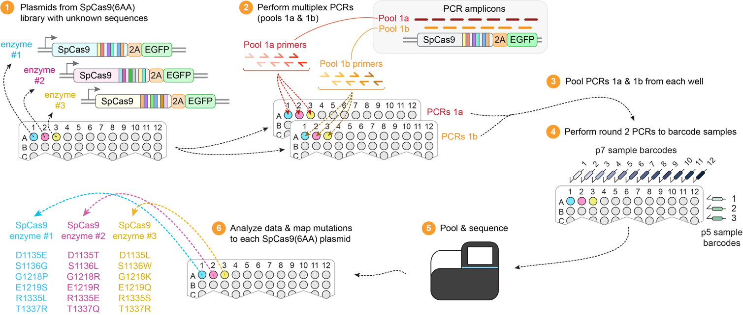

Supplementary Figure 1. Workflow for a whole-ORF sequencing approach. Schematic depicting the workflow used to perform tiled-amplicon sequencing across the entire coding sequences of SpCas9-P2A-EGFP expression plasmids. This inexpensive sequencing method can be performed to obtain complete sequence validation of up to 96 SpCas9 enzyme plasmids in parallel, enabling linkage of amino acid sequence to the specific plasmid based on well position.

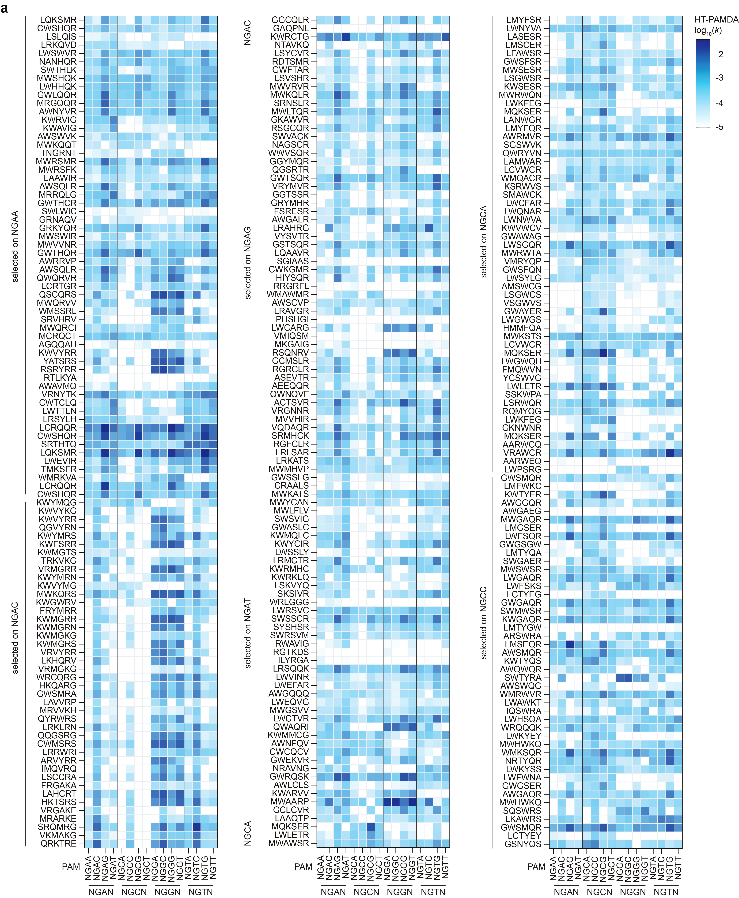

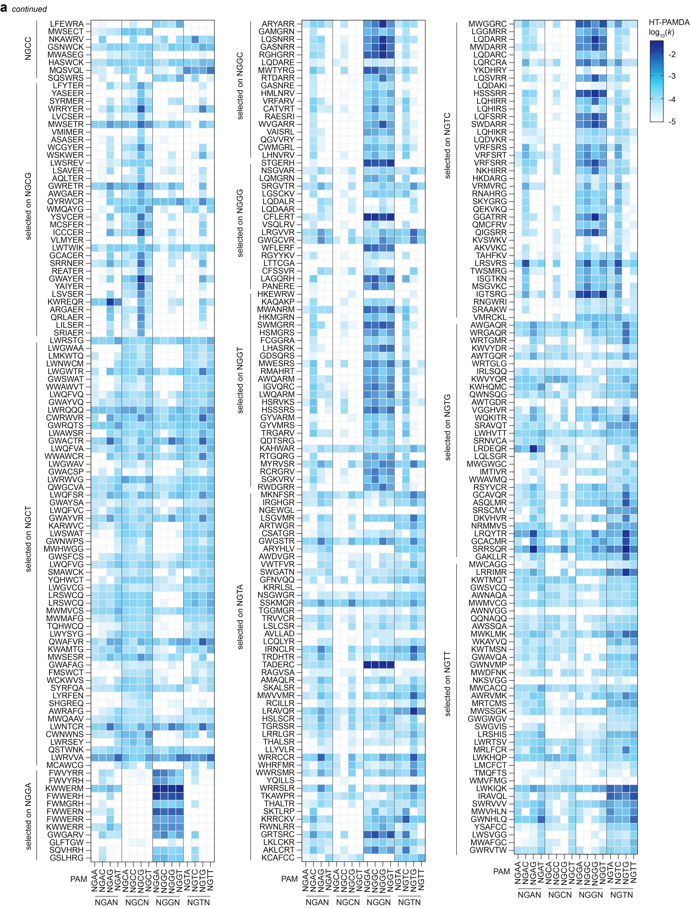

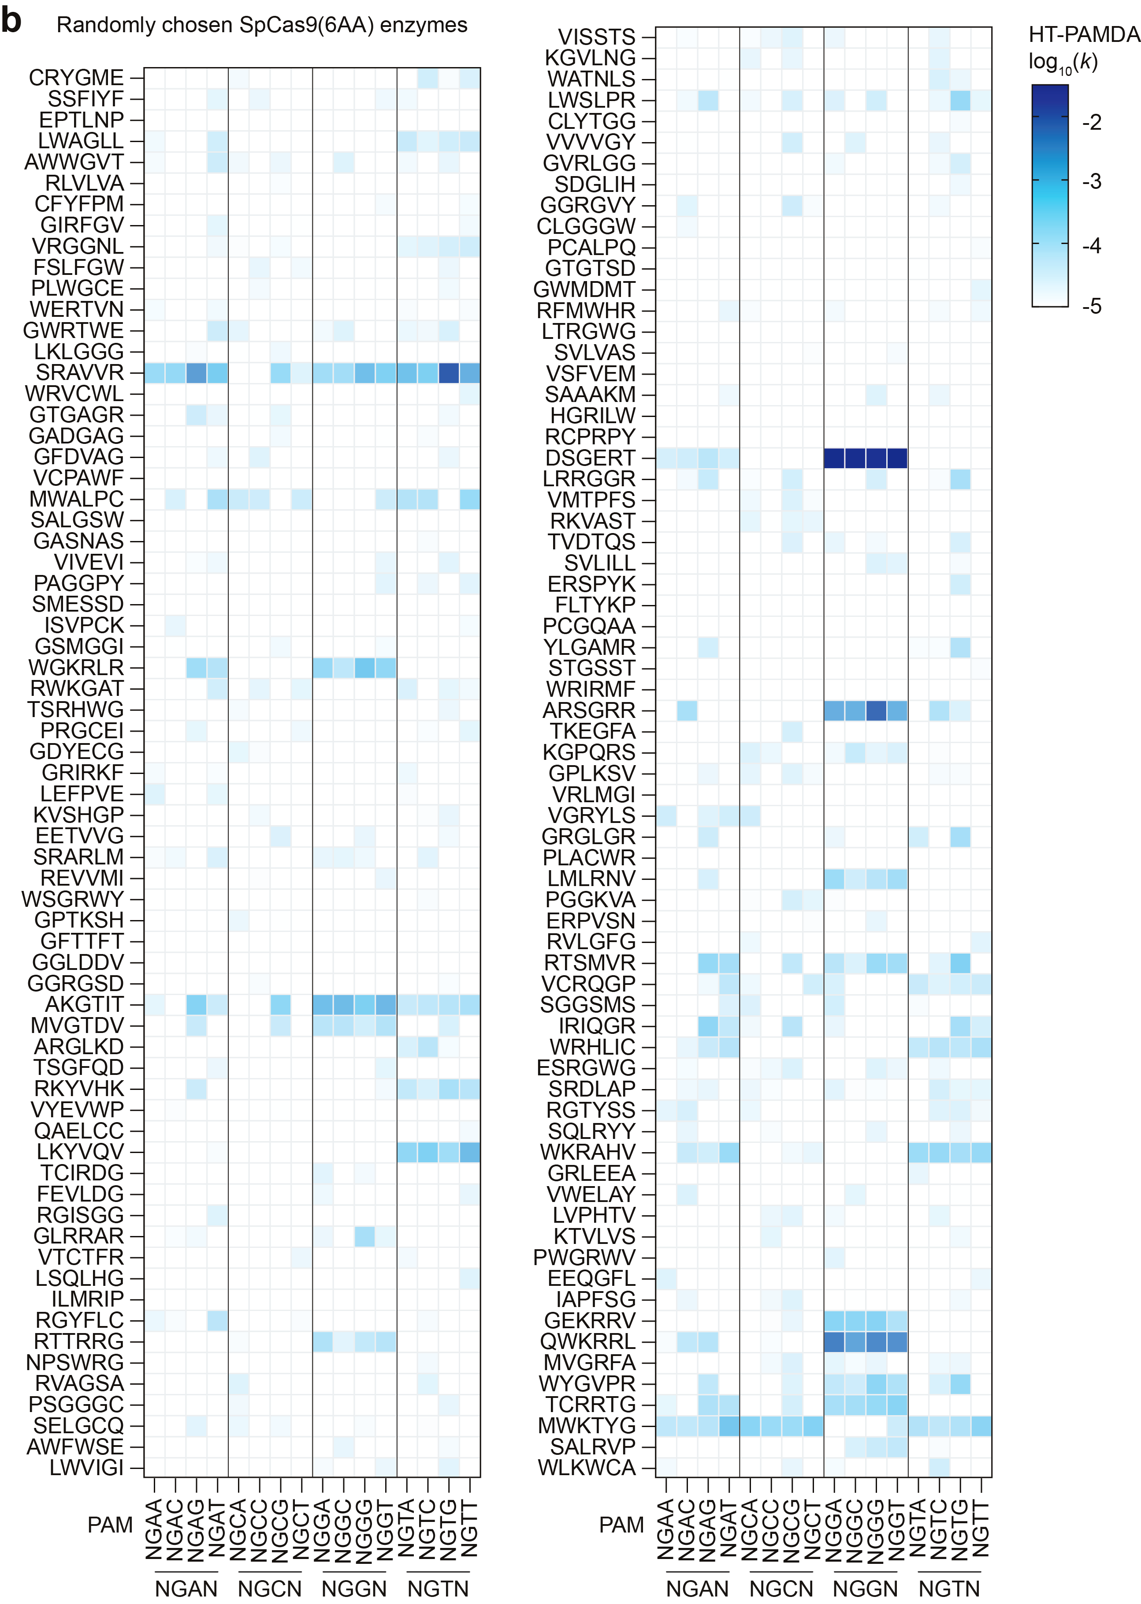
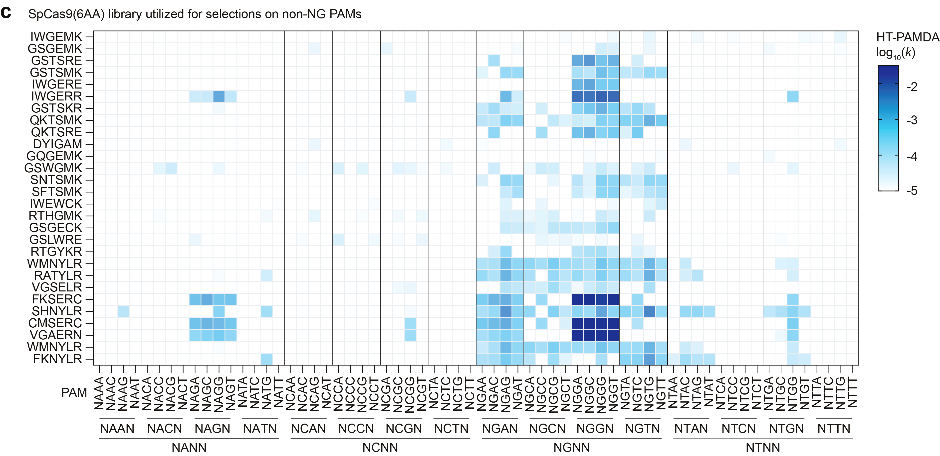

Supplementary Figure 2. PAM profiles for SpCas9 enzymes derived from bacterial selections and random enzymes from the SpCas9(6AA) library. a-c, Experimentally determined PAM profiles for 655 SpCas9 variant enzymes derived from 16 bacterial selections on NGNN PAMs (panel a), for 136 SpCas9 enzymes randomly chosen from the SpCas9(6AA) without undergoing bacterial selections (panel b), and for 28 enzymes from the SpCas9(6AA) library that were derived from bacterial selections on non-NG PAMs (NCNN, NANN, NTNN) (panel c). For all panels, the HT-PAMDA log₁₀ rate constants (k) are the mean of n = 2 replicate experiments performed using two distinct spacer sequences.

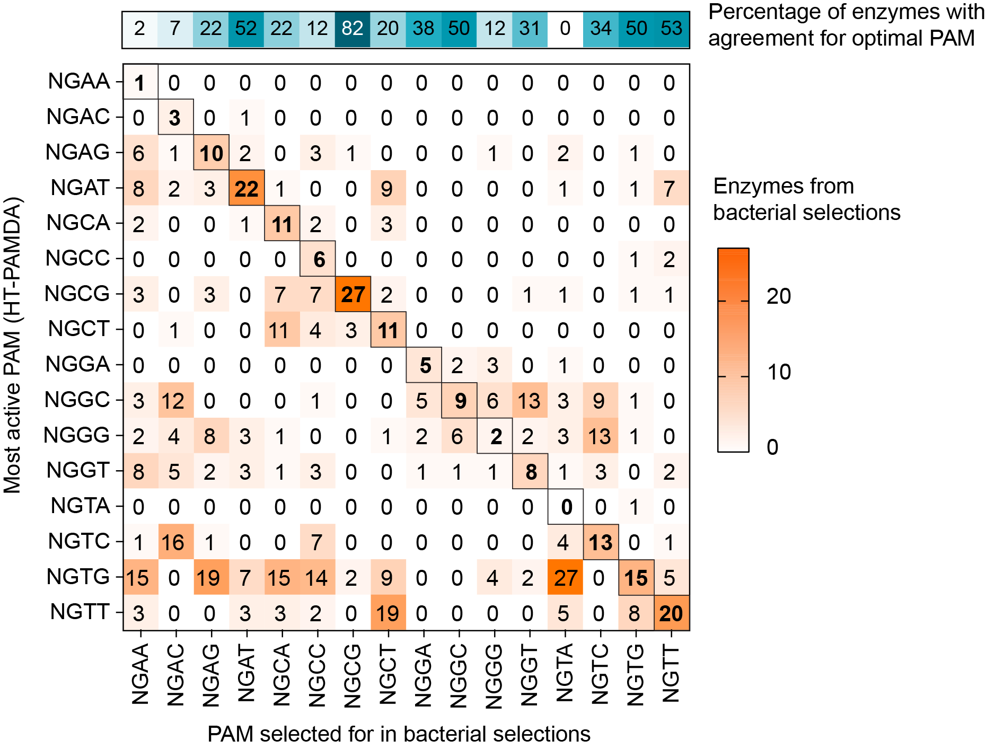

Supplementary Figure 3. Correlation between preferred PAM and sequence selected against. Comparison of most preferred PAM for each enzyme (maximum k determined by HT-PAMDA) compared to the PAM on which each enzyme was selected for during the set of 16 bacterial-based selection experiments on NGNN PAMs. The outlined squares indicate the diagonal where there would be agreement between the most efficiently targeted PAM for the enzyme from HT-PAMDA data compared to the selection PAM.

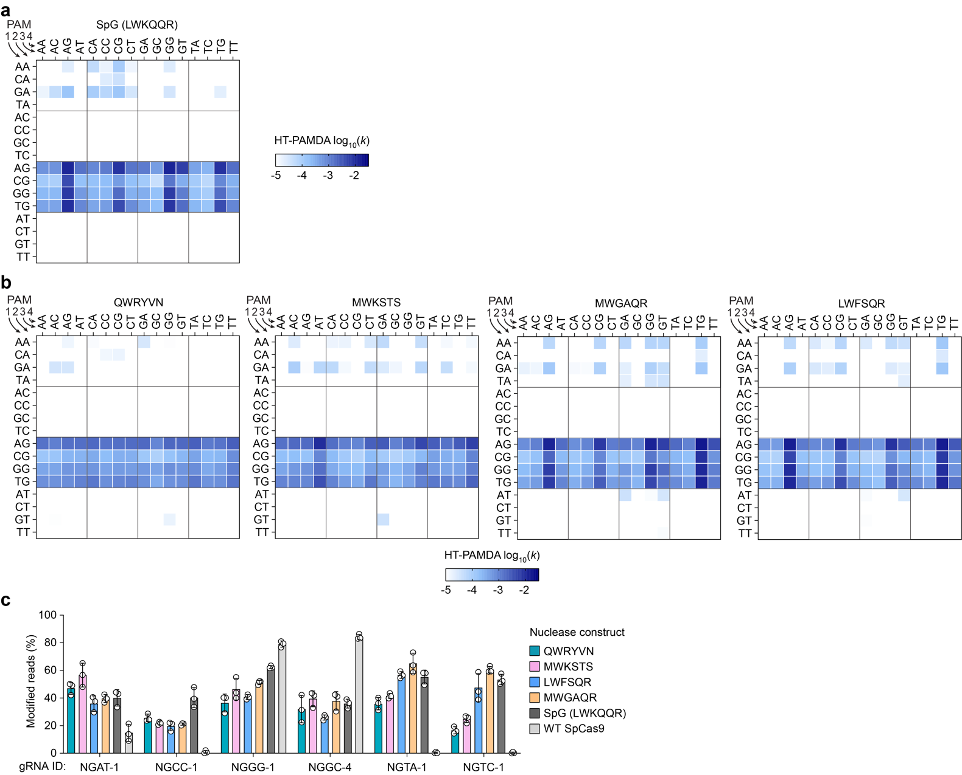

Supplementary Figure 4. PAM preferences of SpCas9 enzymes with relaxed NGN PAM requirements. a,b, Heatmap representations of the PAM profiles of SpCas9 enzymes determined using the HT-PAMDA assay, for the previously described SpG enzyme (panel a), and for newly enzymes with NGN PAM requirements (panel b). SpCas9 variant enzymes are named based on their amino acids at each of the six positions in the SpCas9(6AA) library. The log₁₀ rate constants (k) are the mean of n = 2 replicate HT-PAMDA experiments using two distinct spacer sequences. c, Nuclease-mediated genome editing at six endogenous target sites in HEK 293T cells harboring different PAMs. Editing efficiency was assessed by targeted amplicon sequencing and modified reads were analyzed using CRISPResso2⁴²; mean, standard deviation, and individual datapoints shown for n = 3 independent biological replicates.

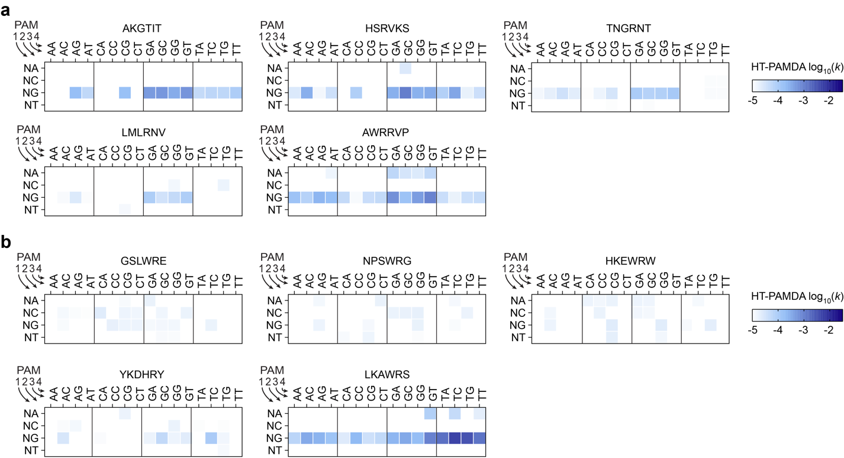

Supplementary Figure 5. Necessity of R1335 for NGG PAM recognition. a,b, Heatmap representations of the PAM profiles of SpCas9 enzyme variants determined using the HT-PAMDA assay, for SpCas9 enzymes obtained through bacterial selections that recognize NGG PAMs but do not contain R1335 (panel a), and for SpCas9 enzymes obtained through bacterial selections that contain R1335 but do not recognize or are not selective for NGG PAMs (panel b). SpCas9 variant enzymes are named based on their amino acids at each of the six positions in the SpCas9(6AA) library. The log₁₀ rate constants (k) are the mean of n = 2 replicate HT-PAMDA experiments using two distinct spacer sequences.

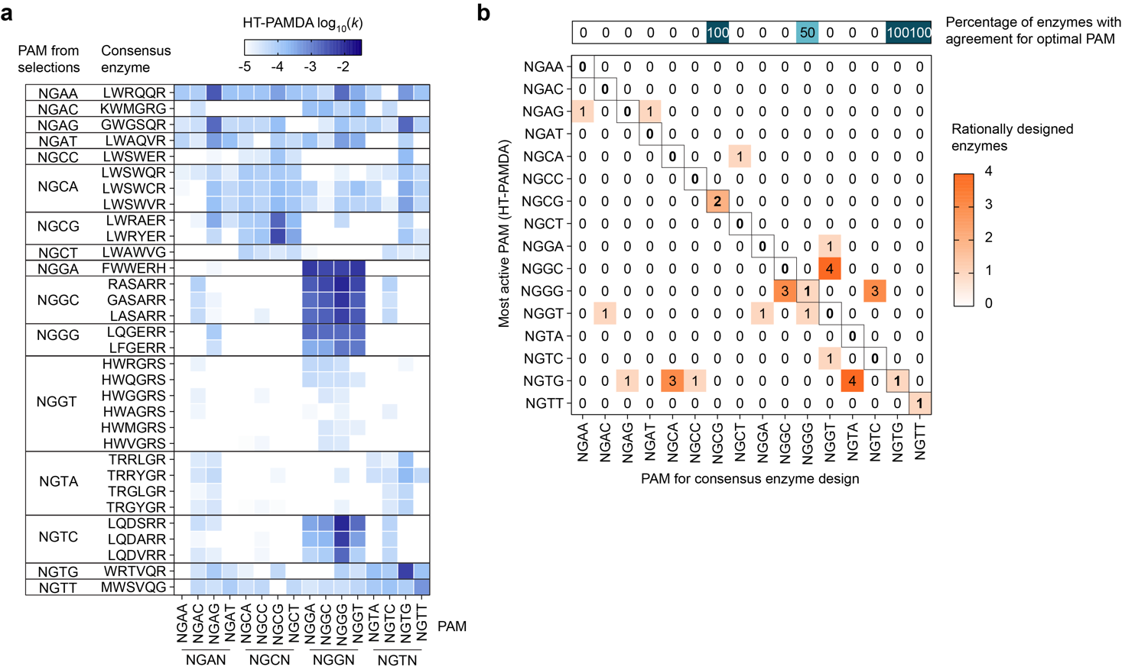

Supplementary Figure 6. Rational design of consensus SpCas9 enzymes resulting from the 16x bacterial selections using NGNN PAMs. a, Heatmap representations of the PAM profiles of SpCas9 ‘consensus enzymes’ determined using the HT-PAMDA assay. Consensus enzymes were rationally designed based on bacterial selection data from each NGNN PAM by combining the most enriched amino acid substitutions at each SpCas9(6AA) library position (see also Extended Data Fig. 2c). If two amino acids were enriched approximately equally, multiple SpCas9 enzymes were cloned and tested. The log₁₀ rate constants (k) are the mean of n = 2 replicate HT-PAMDA experiments using two distinct spacer sequences. SpCas9 variant enzymes are named based on their amino acids at each of the six positions in the SpCas9(6AA) library. (b) Comparison of most preferred PAM for each enzyme (maximum rate constant determined by HT-PAMDA) compared to the PAM that the consensus enzymes were rationally designed to target. The outlined squares indicate the diagonal where there would be agreement between the most efficiently targeted PAM for the enzyme from HT-PAMDA data compared to the PAM for the consensus enzyme.
³⁸
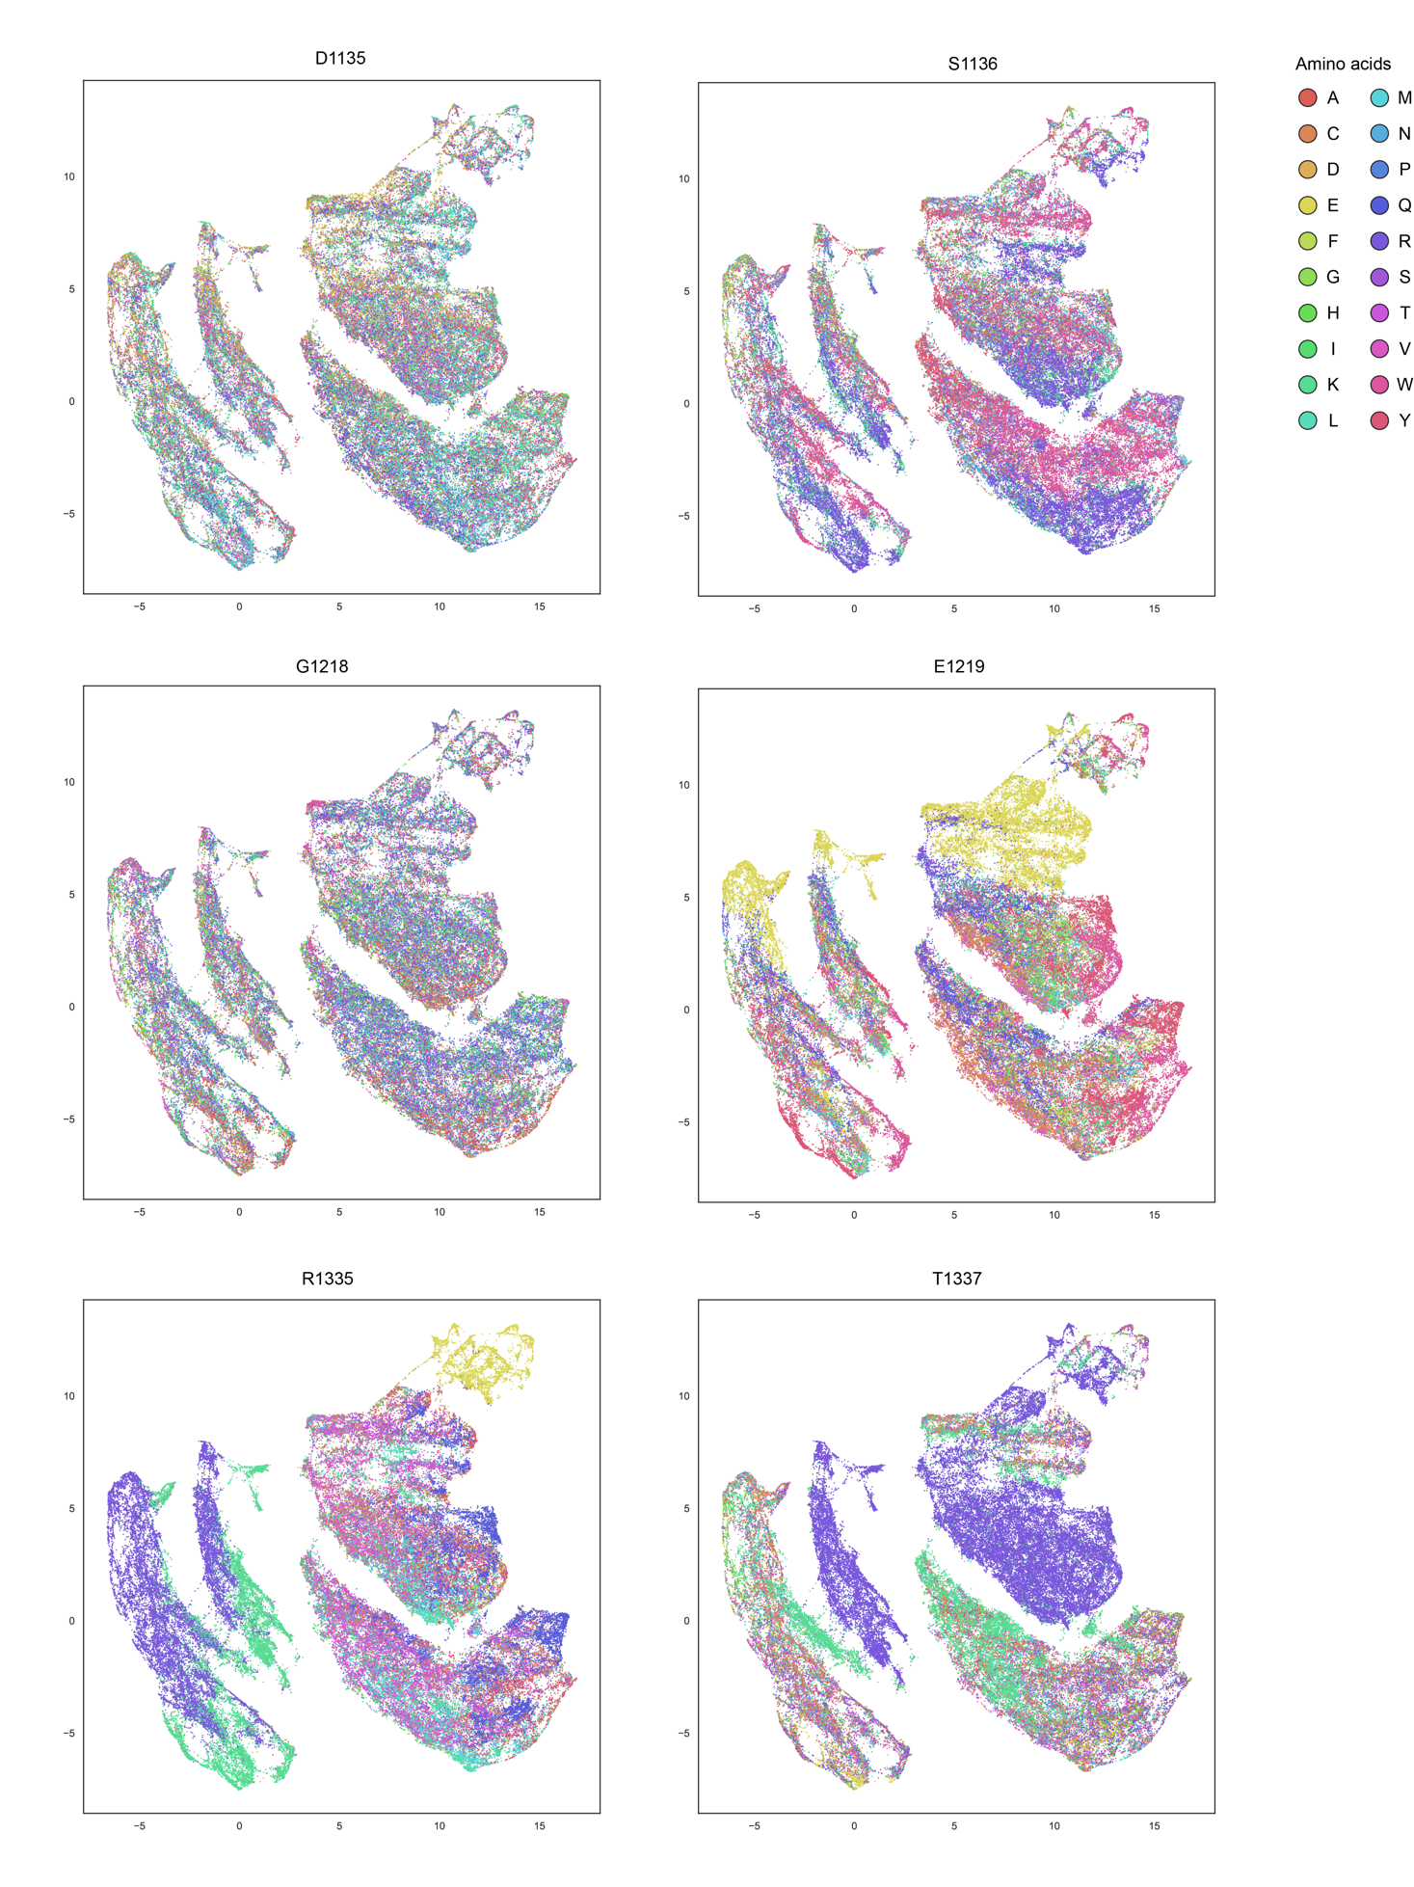
Supplementary Figure 7. PAMmla predictions for 64 million Cas9 variants. PAMmla predicted PAM profiles for all possible 64 million Cas9 enzymes altered at amino positions 1135, 1136, 1218, 1219, 1335, and 1337 were generate and downsampled 100x using scSampler⁴³ to preserve diversity. Enzymes were visualized using UMAP⁴⁴ based on predicted similarity in PAM preference (correlation of 64 PAMmla predicted rate constants). Points are colored according to the amino acid present at each of the 6 varied positions.
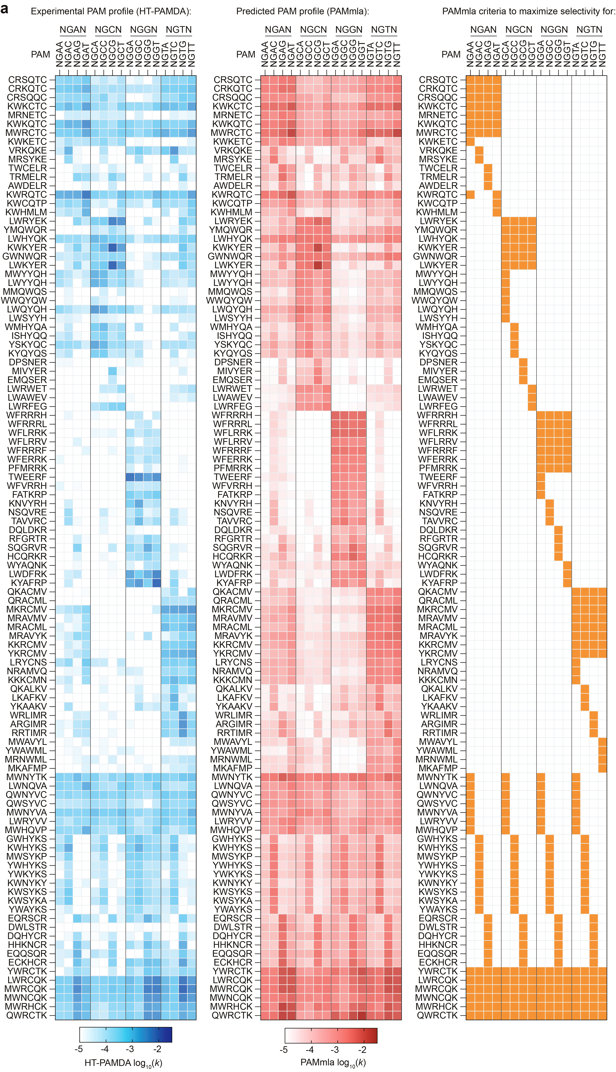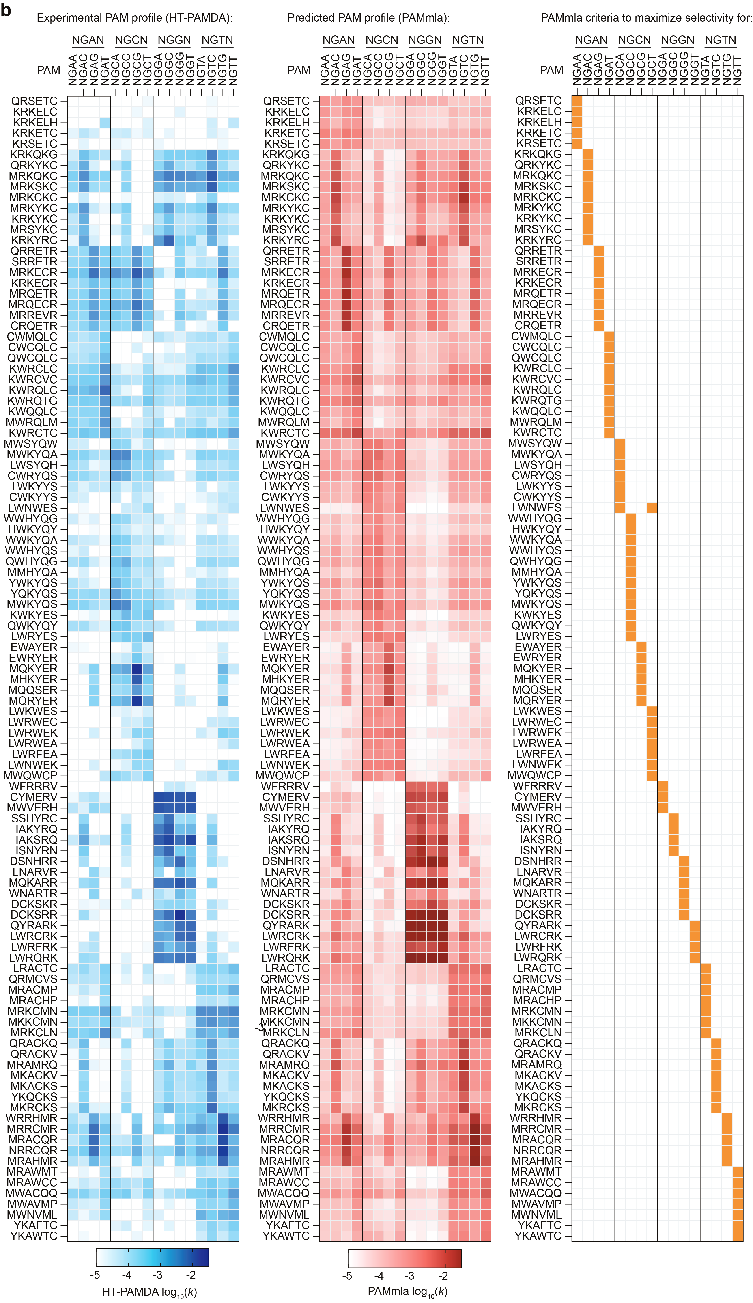
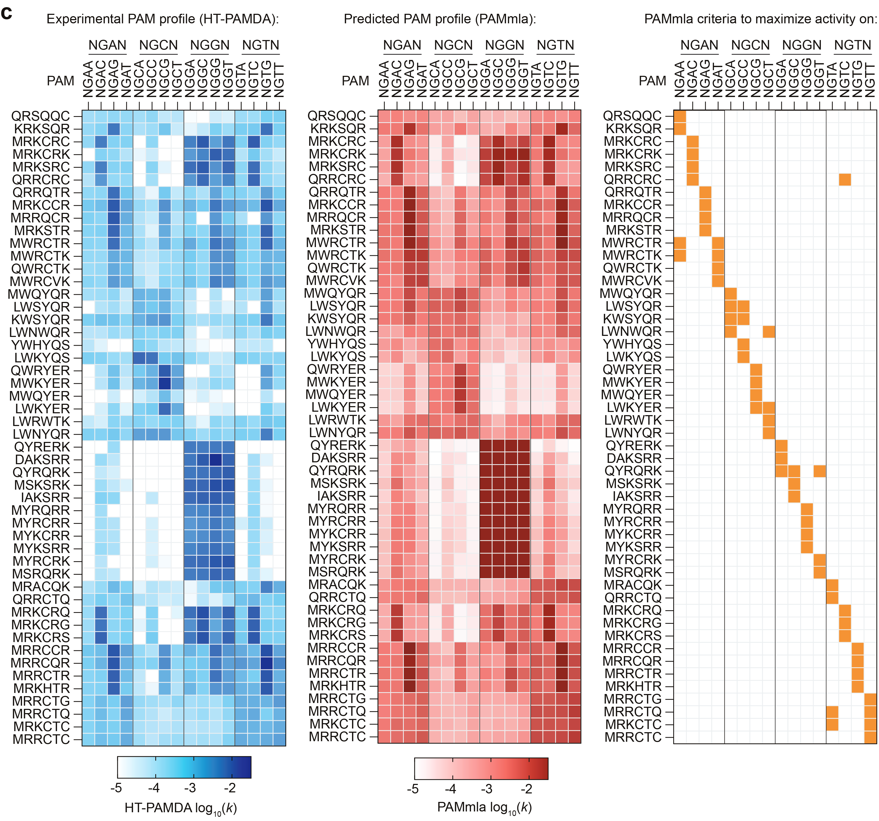

Supplementary Figure 8. PAM profiles and sorting criteria for PAMmla predicted SpCas9 enzymes. a-c, PAM profiles for PAMmla predicted enzymes, including the experimentally validated HT-PAMDA PAM profiles (left panels), PAMmla predicted profiles (center panels), and the sorting criteria used to parse the 64 million PAMmla predictions (right panels). Enzymes were obtained by sorting for maximum selectivity defined as k > 10⁻³ on the PAM(s) of interest and minimizing the sum of ks on all other PAMs (panel a); by sorting for maximum selectivity defined as maximizing the ratio of k on a PAM of interest divided by the sum of ks on all other PAMs (panel b); or by sorting for maximum activity on the PAM of interest (panel c). HT-PAMDA log₁₀ rate constants (k) are the mean of n = 2 replicate HT-PAMDA experiments using two distinct spacer sequences. PAMmla predicted log₁₀ rate constants (k) are the mean of three predictions from separate training instances with different random seeds (model1, model2 and model3).

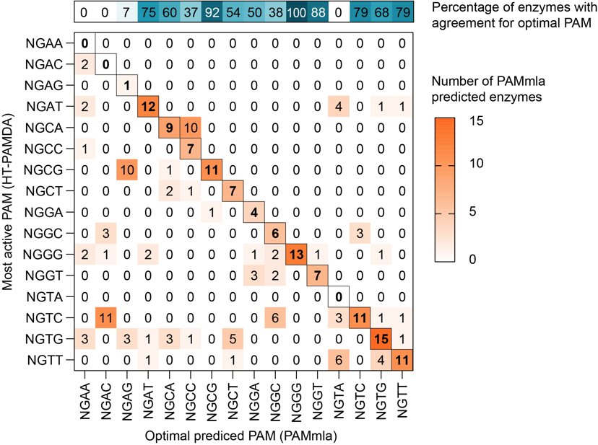

Supplementary Figure 9. Most efficiently targeted PAMs for top PAMmla predicted enzymes. Plot illustrating the proportion of PAMmla predicted enzymes where the most active PAM (ks experimentally assessed via the HT-PAMDA assay) matches the PAMmla predicted maximum k for that enzyme. Outlined squares in the plot indicate the diagonal where there would be agreement between the most efficiently targeted PAM for the enzyme from HT-PAMDA data compared to the PAMmla prediction.

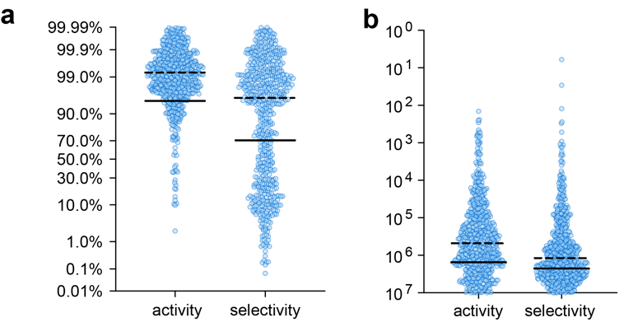

Supplementary Figure 10. Ranking of bacterial selection-derived enzymes amongst the SpCas9(6AA) library. a, Activity and selectivity rankings of SpCas9 PAM variant enzymes derived from bacterial selections ranked within the full set of 64 million PAMmla predicted enzymes. Rate constants (k) and selectivity (k/sum(all ks)) for the PAM on which each enzyme from bacterial selections was obtained were ranked amongst the distribution of activities/selectivites within the entire prediction set. Each datapoint represents the ranking of an enzyme derived from bacterial selections. The background distribution of all rate constants and selectivities for each of the 16 NGNN PAMs within the 6AA library was estimated by taking a random sample of 1 million enzymes from the library and generating PAMmla predictions. b, Corresponding number of PAMmla predicted enzyme variants amongst the 64 million SpCas9(6AA) library that are predicted to exhibit improved activity or specificity compared to each enzyme in panel a. For panels a and b, solid lines represent means and dashed lines represent medians.

²⁴¹³⁴¹²³⁴²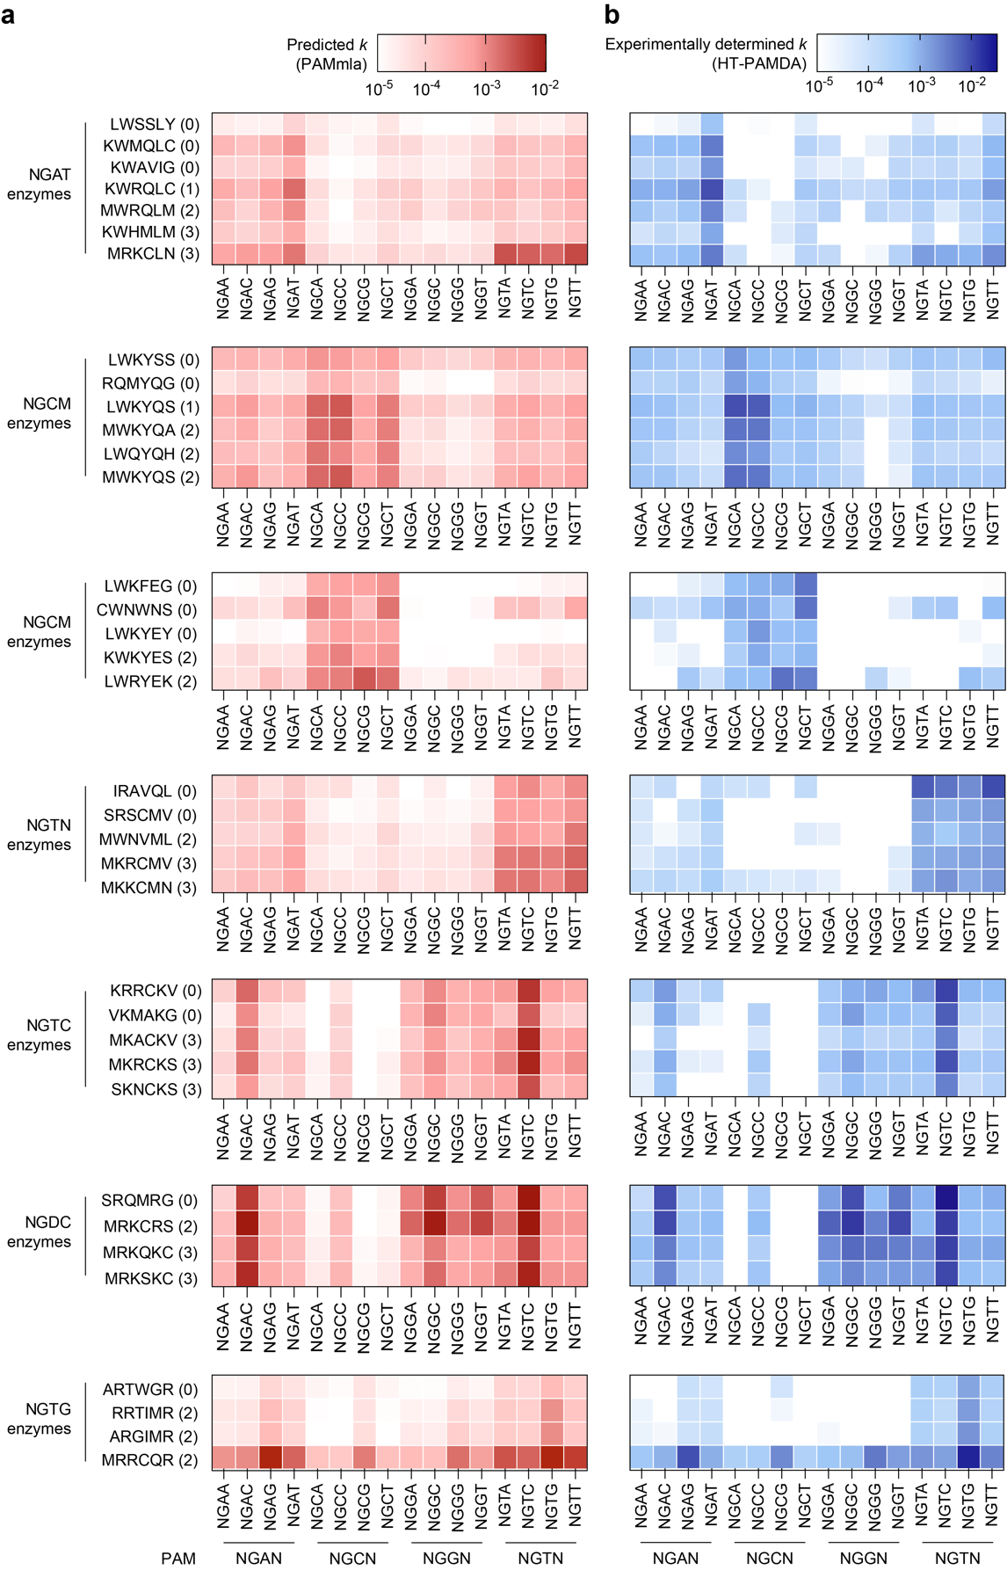

Supplementary Figure 11. Experimental and predicted PAM profiles for engineered SpCas9 enzymes. a,b, Comparison of PAMmla predicted rate constants (panel a) to HT-PAMDA determined rate constants (panel b) for enzyme variants chosen for human cell validation in Figure 4.
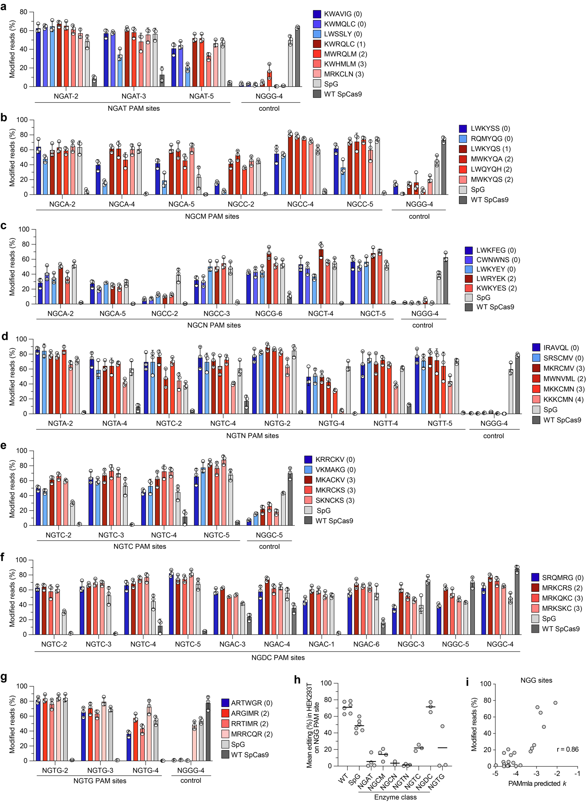

Supplementary Figure 12. Genome editing in human cells with PAMmla predicted enzymes. a-g, Nuclease-mediated genome editing at endogenous target sites in HEK 293T cells harboring different PAMs for wild-type (WT) SpCas9, SpG, and PAMmla predicted enzymes capable of targeting various classes of PAMs (NGAT, NGCM, NGCN, NGTN, NGTC, NGDC, and NGTG in panels a-g, respectively). SpCas9 variant enzymes are named based on their amino acids at each of the six positions in the SpCas9(6AA) library. Enzymes resulting from bacterial selections are colored in shades of blue (hamming distance (HD) of 0) and PAMmla predicted enzymes are shown in shades of red (HD for each enzyme indicated in parentheses). The site encoding an NGGC PAM was used as a negative control for editing with the PAMmla predicted enzymes. Editing efficiency was assessed by targeted amplicon sequencing and modified reads were analyzed using CRISPResso2; mean, standard deviation, and individual datapoints are shown for n = 3 independent biological replicates. h, Summary of editing efficiencies for PAMmla predicted enzymes against the NGG PAM control site in HEK 293T cells tested in panels a-g. i, Correlation between PAMmla predicted rate constant for the control NGG PAM tested for each enzyme in panels a-g versus the mean observed editing in HEK 293T cells at that PAM site. Enzymes predicted by PAMmla to have low activity on NGG PAMs showed low editing on NGG sites in human cells.

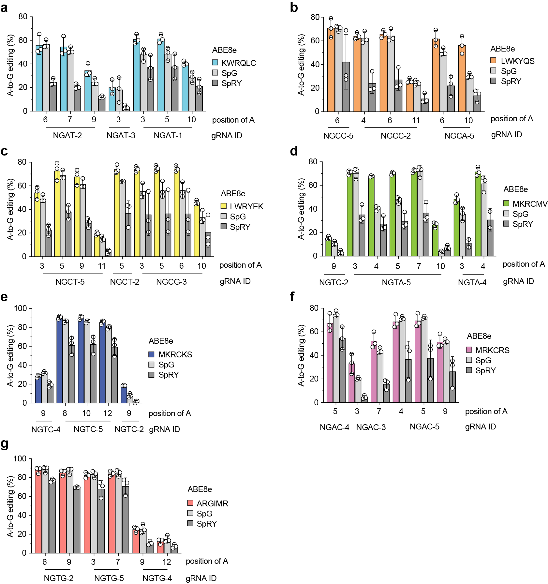

Supplementary Figure 13. A-to-G base editing with PAMmla predicted enzymes. a-g, A-to-G base editing efficiencies using ABE8e⁴⁵ enzymes for genome editing at endogenous target sites in HEK 293T cells harboring different PAMs for SpG, SpRY, and PAMmla predicted enzymes capable of targeting various classes of PAMs (NGAT, NGCM, NGCN, NGTN, NGTC, NGDC, and NGTG in panels a-g, respectively). SpCas9 variant enzymes are named based on their amino acids at each of the six positions in the SpCas9(6AA) library. Editing efficiency was assessed by targeted amplicon sequencing and modified reads were analyzed using CRISPResso2; mean, standard deviation, and individual datapoints are shown for n = 3 independent biological replicates. Datapoints for all adenine bases in the ABE8e edit window (positions 4-9 of the spacer, counting from the PAM distal end) or any other adenine in the spacer sequence edited >5% are shown.

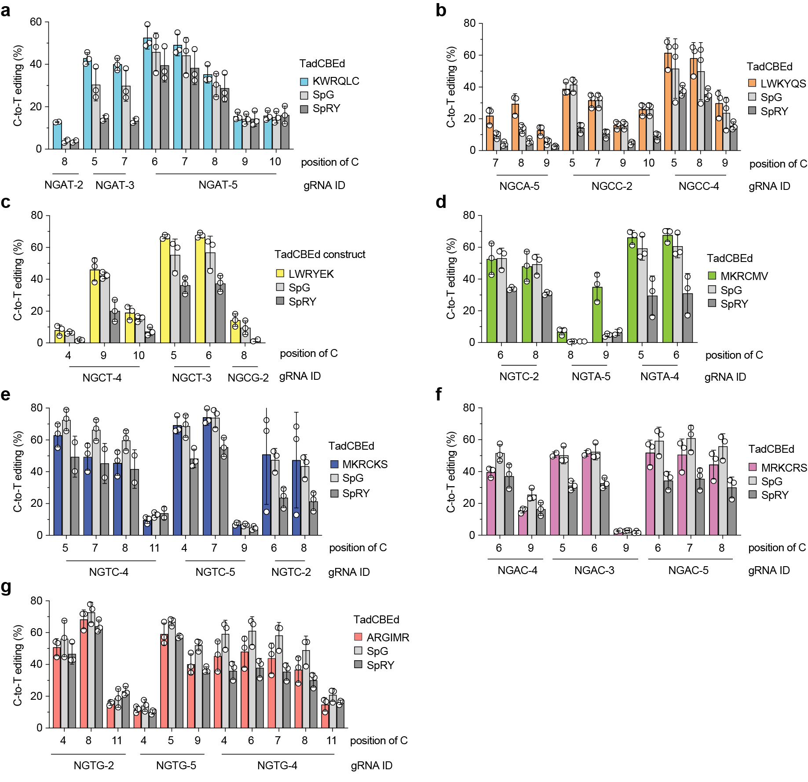

Supplementary Figure 14. C-to-T base editing with PAMmla predicted enzymes. a-g, C-to-T base editing efficiencies using TadCBEd⁴⁶ enzymes for genome editing at endogenous target sites in HEK 293T cells harboring different PAMs for SpG, SpRY, and PAMmla predicted enzymes capable of targeting various classes of PAMs (NGAT, NGCM, NGCN, NGTN, NGTC, NGDC, and NGTG in panels a-g, respectively). SpCas9 variant enzymes are named based on their amino acids at each of the six positions in the SpCas9(6AA) library. Editing efficiency was assessed by targeted amplicon sequencing and modified reads were analyzed using CRISPResso2; mean, standard deviation, and individual datapoints are shown for n = 3 independent biological replicates. Datapoints for all cytosine bases in the TadCBEd edit window (positions 4-9 of the spacer, counting from the PAM distal end) or any other cytosine in the spacer sequence edited >5% are shown.
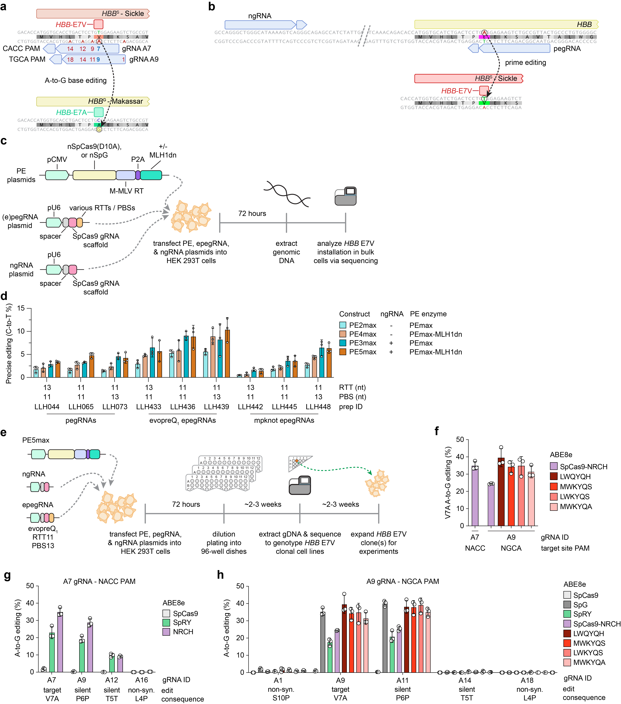

Supplementary Figure 15. Creation of a sickle cell HBB E7V cell line and base editing with ML-derived PAM variants. a, Schematic of using ABEs paired with A7 or A9 sgRNAs to edit the HBB E7V sickle cell allele (HBB^{S}) into Makassar β-globin allele (HBB^{G}), with intended edit position and bystander edits labeled (with blue or red numbering, respectively). b, Schematic of a region of the human HBB gene surrounding amino acid E7. To install the HBB E7V mutation, prime editing guide RNA (pegRNA) target sites and nicking sgRNA target sites (ngRNAs) were designed for compatibility with NGG PAMs. c, Workflow for assessing the editing efficiencies of different prime editor (PE) constructs, pegRNAs, and ngRNAs to generate the HBB E7V mutation in HEK 293T cells in bulk transfection experiments. d, Precise prime editing efficiencies using to generate the HBB E7V mutation in HEK 293T cells. Editing efficiencies were assessed by targeted amplicon sequencing and modified reads were analyzed using CRISPResso2; mean, standard deviation, and individual datapoints shown for n = 3 independent biological replicates. e, Workflow for generating a clonal HEK 293T cell line harboring the HBB E7V mutation using PE4max, the evopreQ₁ RTT11-PBS13 epegRNA, and ngRNA. f, A-to-G editing of only the target adenine to convert HBB^{S} into HBB^{G} using PAMmla-derived editors with the A9 sgRNA (targeting a site with an NGCA PAM) compared to editing with ABE8e-SpCas9-NRCH¹⁶ with the A9 sgRNA or the previously reported³⁰ A7 sgRNA (that targets a site with an NACC PAM). g,h, Analysis of on-target A-to-G editing along with bystander editing of neighboring adenines for experiments using sgRNA A7 (panel g) or sgRNA A9 (panel h). For panels f-h, experiments performed in the HEK 293T cell line harboring the HBB E7V mutation; base editing efficiencies were assessed by targeted amplicon sequencing and modified reads were analyzed using CRISPResso2; mean, standard deviation, and individual datapoints shown for n = 3 independent biological replicates.
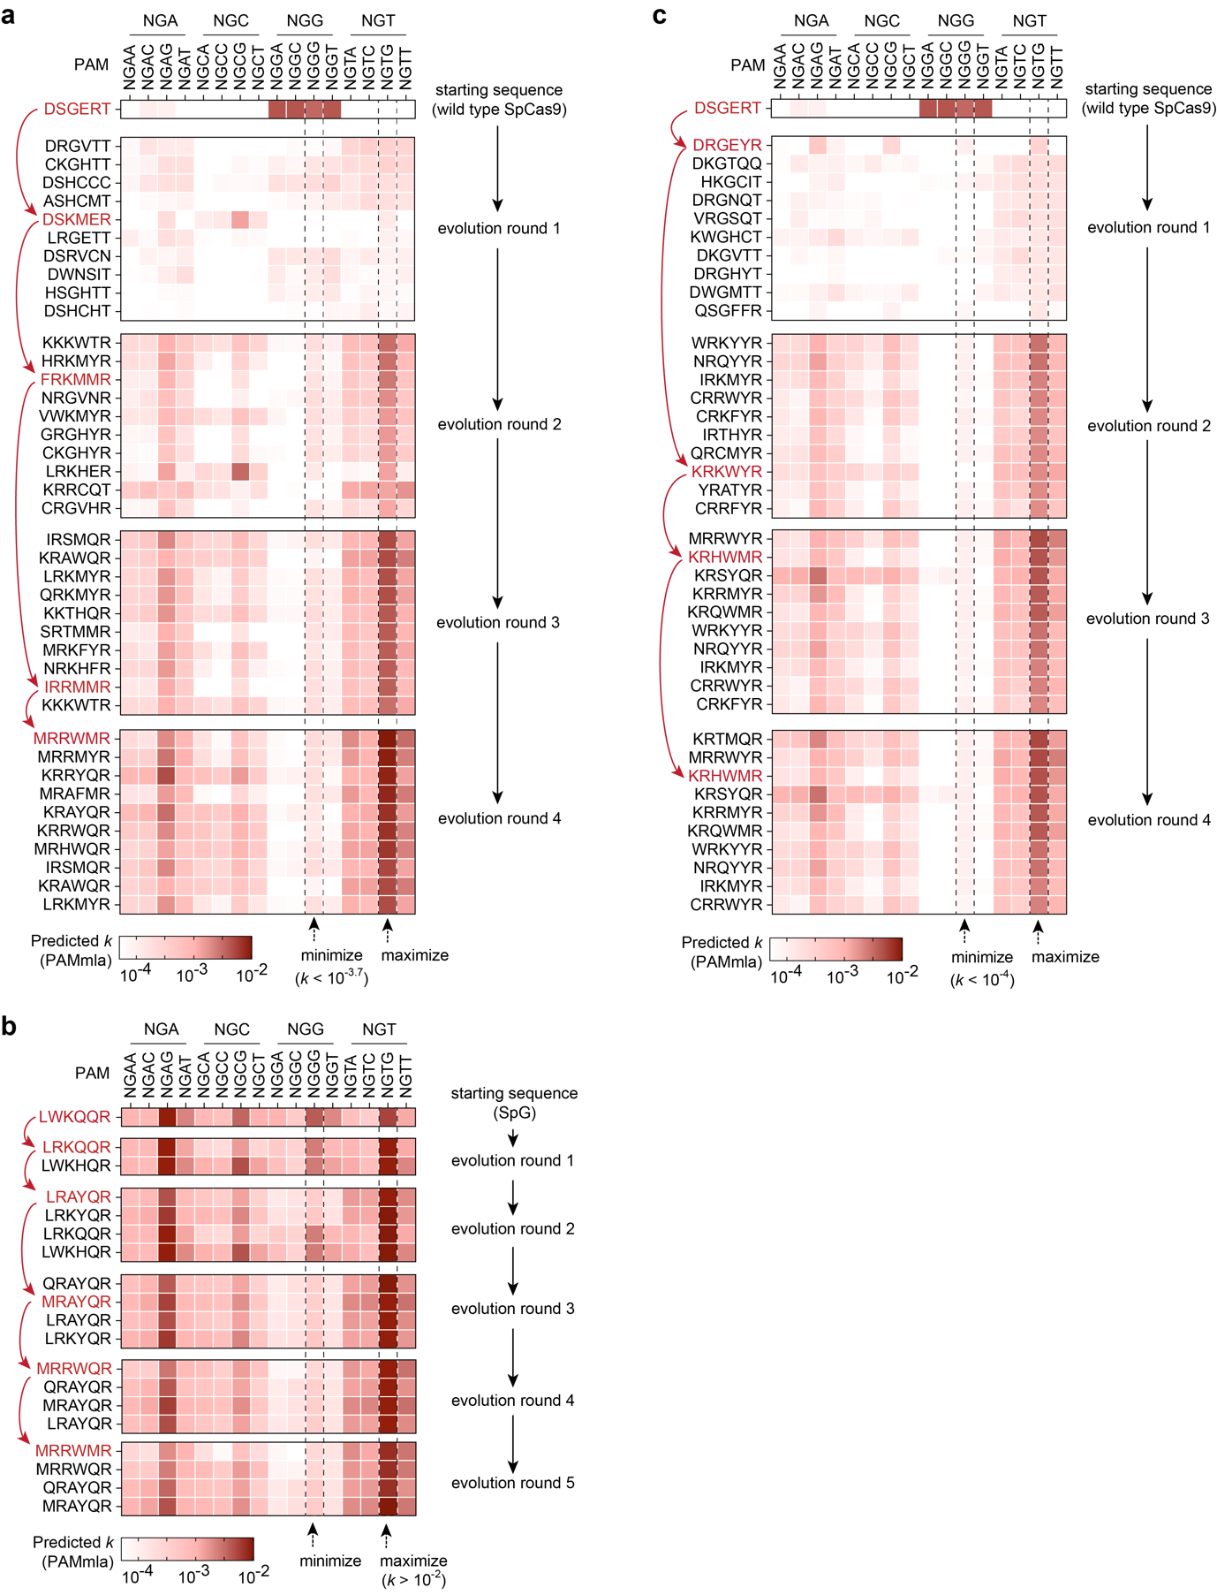

Supplementary Figure 16. in silico directed evolution of PAM-selective SpCas9 enzymes. a, In silico directed evolution (ISDE) trajectory starting from wild-type (WT) SpCas9 and evolving towards maximizing efficiency on sites with NGTG PAMs, while minimizing activity on sites with NGGG PAMs (setting the PAMmla predicted k for NGGG to < 10^{-3.7}). The top ten enzymes were kept per round of ISDE and the predicted ks are shown; four mutations were permitted per enzyme during mutagenesis. b, Results of PAMmla-enabled ISDE starting with SpG (encoding LWKQQR amino acids within the SpCas9(6AA) library), with ISDE parameters to maximize activity on NGTG PAMs (> k = 10⁻²) and minimize on NGGG PAMs. The top four enzymes were kept per round of ISDE and the predicted ks are shown; two mutations were permitted per enzyme during mutagenesis. c, ISDE trajectory starting from WT SpCas9 and evolving towards maximizing efficiency on NGTG PAMs and minimizing activity on NGGG PAMs (k < 10⁻⁴). The top ten enzymes were kept per round of ISDE and the predicted ks are shown; four mutations were permitted per enzyme during mutagenesis. SpCas9 variant enzymes are named based on their amino acids at each of the six positions in the SpCas9(6AA) library; the evolutionary trajectories of the enzymes with the highest fitness are shown in red.

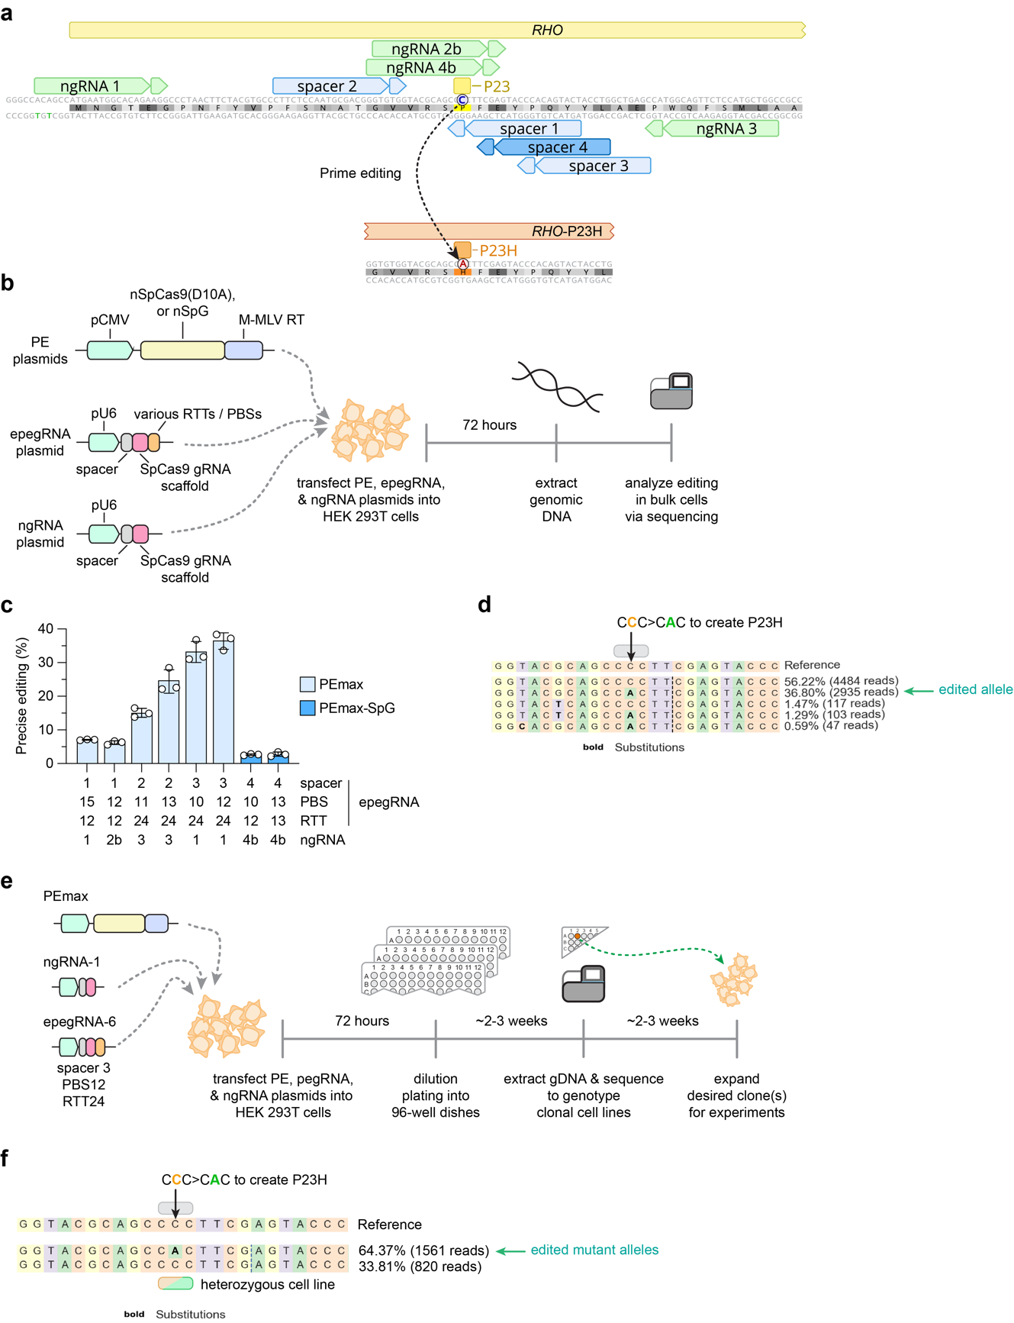

Supplementary Figure 17. Prime editing to create a RHO P23H cell line. a, Schematic of a region of the human RHO gene surrounding amino acid P23. To install the RHO P23H mutation, pegRNA target sites and ngRNAs were designed for compatibility with NGG or NAG PAMs. b, Workflow for assessing the editing efficiencies of different prime editor (PE) constructs, pegRNAs, and ngRNAs to generate the RHO P23H mutation in HEK 293T cells in bulk transfection experiments. c, Precise prime editing efficiencies using to generate the RHO P23H in HEK 293T cells. Editing efficiencies were assessed by targeted amplicon sequencing and modified reads were analyzed using CRISPResso2; mean, standard deviation, and individual datapoints shown for n = 3 independent biological replicates. d, Representative targeted sequencing result for a bulk population of HEK 293T cells that were transfected with PEmax, the spacer #3 RTT24-PBS12 epegRNA, and ngRNA #1, analyzed using CRISPResso. The desired RHO P23H edit was achieved in >35% of alleles. e, Workflow for generating a clonal HEK 293T cell line harboring the RHO P23H mutation using PEmax, spacer #3 RTT24-PBS12 epegRNA, and ngRNA #1. f, Representative targeted sequencing result for a clonal heterozygous RHO P23H HEK 293T cell line harboring 2 mutant alleles and 1 wild-type allele, analyzed using CRISPResso2.

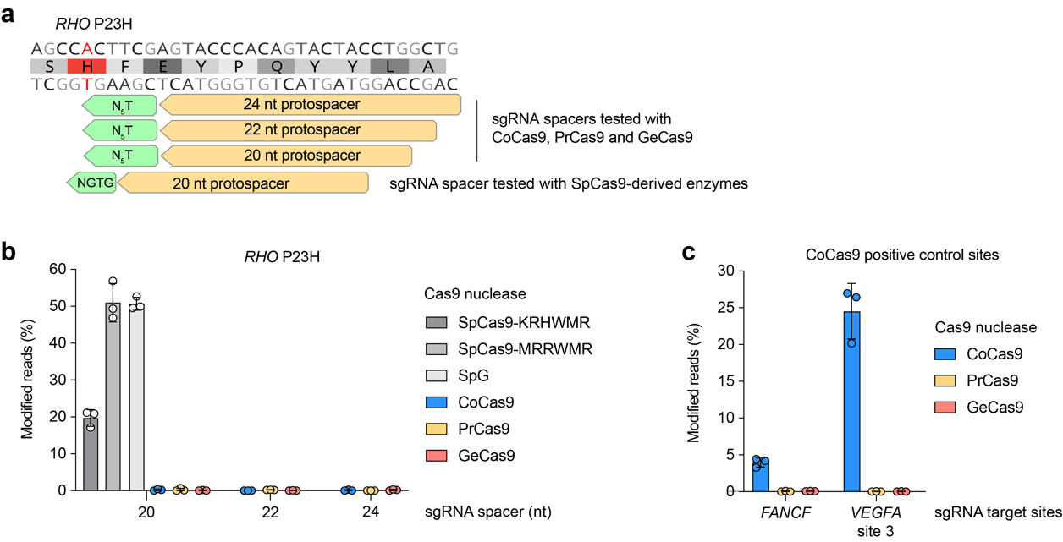

Supplementary Figure 18. Assessment of Cas9 orthologs for allele-specific targeting of RHO P23H. a, Schematic of RHO P23H target sites. b, Nuclease-mediated genome editing at the RHO P23H locus in homozygous P23H HEK 293T cells, utilizing sgRNA and enzyme expression plasmids for PAMmla-predicted SpCas9-KRHWMR and -MRRWMR, SpG, CoCas9³² (N₄GT PAM), GeCas9³² (N₄GT PAM), and PrCas9³¹ (N₅T PAM). sgRNAs encoding three different spacer lengths were tested for the non-SpCas9 enzymes. c, Editing at previously described positive control genomic sites for CoCas9³² (for PrCas9 and GeCas9, the same spacer sequences were used but combined with the ortholog-specific scaffold sequences^{32,31}. Editing efficiencies in panels b,c were assessed by targeted amplicon sequencing and modified reads were analyzed using CRISPResso2; mean, standard deviation, and individual datapoints shown for n = 3 technical replicates.

²⁴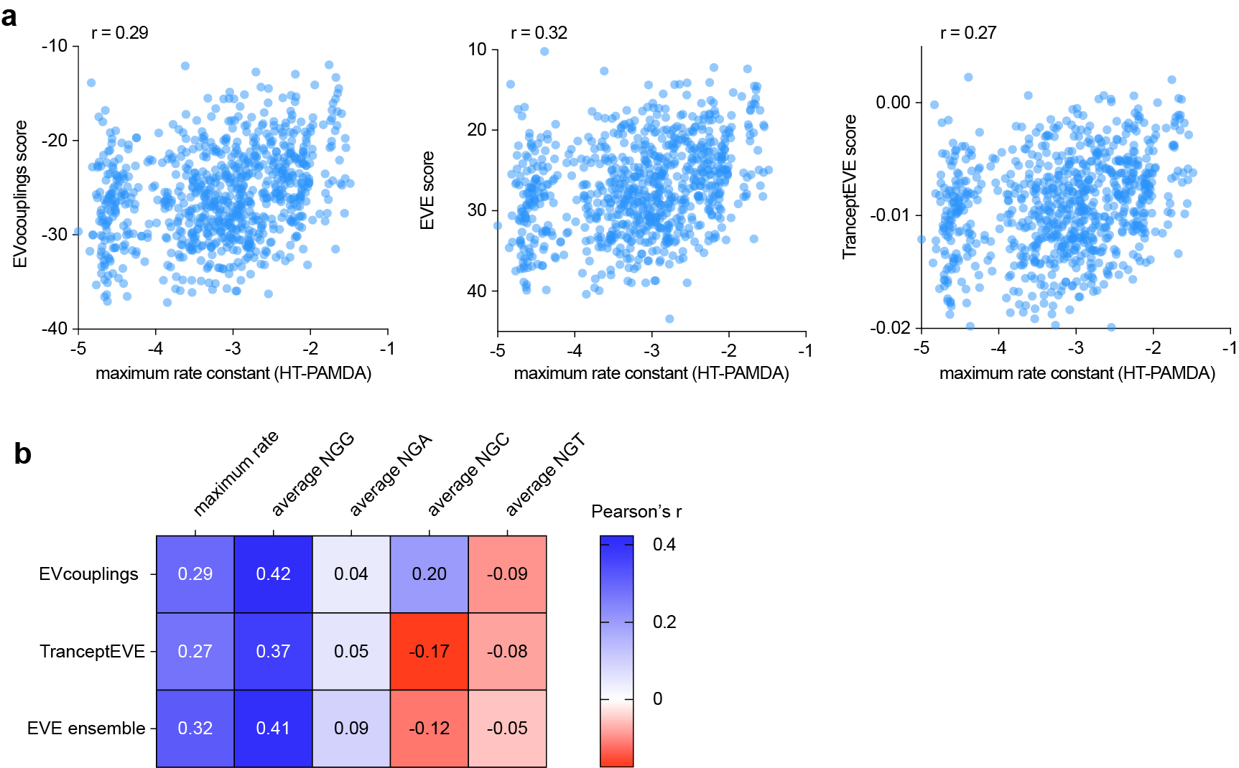

Supplementary Figure 19. Comparison of HT-PAMDA datasets with evolutionary model predictions. a, Evolutionary scores generated using EVcouplings⁴⁷, EVE⁴⁸, and TranceptEVE⁴⁹ trained on 1,296 Cas9 related protein sequences from the UniRef100 sequence database were compared to the maximum HT-PAMDA rate constant across all PAMs for each of the bacterial selected and randomly chosen variants from the SpCas9(6AA) library. b, Pearson’s correlations for each set of evolutionary model scores with the HT-PAMDA dataset from the SpCas9(6AA) library. Rate constants used were 1) rate constants on the maximum PAM for each variant and 2) the average rate constants across NGG, across NGA, across NGC and across NGT PAMs.

Supplementary References
1. Christie, K. A. & Kleinstiver, B. P. Making the cut with PAMless CRISPR-Cas enzymes. Trends in Genetics 37, 1053–1055 (2021).
2. Rees, H. A. & Liu, D. R. Base editing: precision chemistry on the genome and transcriptome of living cells. Nat Rev Genet 19, 770 (2018).
3. Gaudelli, N. M. et al. Programmable base editing of T to G C in genomic DNA without DNA cleavage. Nature (2017) doi:10.1038/nature24644.
4. Porto, E. M., Komor, A. C., Slaymaker, I. M. & Yeo, G. W. Base editing: advances and therapeutic opportunities. Nature Reviews Drug Discovery 2020 19:12 19, 839–859 (2020).
5. Komor, A. C., Kim, Y. B., Packer, M. S., Zuris, J. A. & Liu, D. R. Programmable editing of a target base in genomic DNA without double-stranded DNA cleavage. Nature 2015 533:7603 533, 420–424 (2016).
6. Landrum, M. J. et al. ClinVar: Public archive of relationships among sequence variation and human phenotype. Nucleic Acids Res (2014) doi:10.1093/nar/gkt1113.
7. Chatterjee, P. et al. A Cas9 with PAM recognition for adenine dinucleotides. Nature Communications 2020 11:1 11, 1–6 (2020).
8. Zhao, L. et al. PAM-flexible genome editing with an engineered chimeric Cas9. Nature Communications 2023 14:1 14, 1–8 (2023).
9. Chatterjee, P. et al. An engineered ScCas9 with broad PAM range and high specificity and activity. Nature Biotechnology 2020 38:10 38, 1154–1158 (2020).
10. Kleinstiver, B. P. et al. Broadening the targeting range of Staphylococcus aureus CRISPR-Cas9 by modifying PAM recognition. Nat Biotechnol 33, 1293–1298 (2015).
11. Huang, T. P. et al. High-throughput continuous evolution of compact Cas9 variants targeting single-nucleotide-pyrimidine PAMs. Nature Biotechnology 2022 41:1 41, 96–107 (2022).
12. Nishimasu, H. et al. Engineered CRISPR-Cas9 nuclease with expanded targeting space. Science (1979) (2018) doi:10.1126/science.aas9129.
13. Hu, J. H. et al. Evolved Cas9 variants with broad PAM compatibility and high DNA specificity. Nature (2018) doi:10.1038/nature26155.
14. Zhong, Z. et al. Improving Plant Genome Editing with High-Fidelity xCas9 and Non-canonical PAM-Targeting Cas9-NG. Mol Plant 12, 1027–1036 (2019).
15. Walton, R. T., Christie, K. A., Whittaker, M. N. & Kleinstiver, B. P. Unconstrained genome targeting with near-PAMless engineered CRISPR-Cas9 variants. Science (1979) (2020) doi:10.1126/science.aba8853.
16. Miller, S. M. et al. Continuous evolution of SpCas9 variants compatible with non-G PAMs. Nat Biotechnol (2020) doi:10.1038/s41587-020-0412-8.
17. Zhang, W. et al. In-depth assessment of the PAM compatibility and editing activities of Cas9 variants. Nucleic Acids Res 49, 8785–8795 (2021).
18. Hibshman, G. N. et al. Unraveling the mechanisms of PAMless DNA interrogation by SpRY Cas9. bioRxiv 2023.06.22.546082 (2023) doi:10.1101/2023.06.22.546082.
19. Wu, Y. et al. Genome-wide analyses of PAM-relaxed Cas9 genome editors reveal substantial off-target effects by ABE8e in rice. Plant Biotechnol J 20, 1670–1682 (2022).
20. Anders, C., Niewoehner, O., Duerst, A. & Jinek, M. Structural basis of PAM-dependent target DNA recognition by the Cas9 endonuclease. Nature (2014) doi:10.1038/nature13579.
21. Kleinstiver, B. P. et al. Engineered CRISPR-Cas9 nucleases with altered PAM specificities. Nature (2015) doi:10.1038/nature14592.
22. Anders, C., Bargsten, K. & Jinek, M. Structural Plasticity of PAM Recognition by Engineered Variants of the RNA-Guided Endonuclease Cas9. Mol Cell (2016) doi:10.1016/j.molcel.2016.02.020.
23. Kleinstiver, B. P. et al. High-fidelity CRISPR-Cas9 variants with undetectable genome-wide off-targets. Nature 529, 490 (2016).
24. Hirano, S., Nishimasu, H., Ishitani, R. & Nureki, O. Structural Basis for the Altered PAM Specificities of Engineered CRISPR-Cas9. Mol Cell (2016) doi:10.1016/j.molcel.2016.02.018.
25. Christie, K. A. et al. Precise DNA cleavage using CRISPR-SpRYgests. Nature Biotechnology 2022 41:3 41, 409–416 (2022).
26. Gibson, D. G. et al. Enzymatic assembly of DNA molecules up to several hundred kilobases. Nature Methods 2009 6:5 6, 343–345 (2009).
27. Kleinstiver, B. P., Fernandes, A. D., Gloor, G. B. & Edgell, D. R. A unified genetic, computational and experimental framework identifies functionally relevant residues of the homing endonuclease I-BmoI. Nucleic Acids Res 38, 2411 (2010).
28. Anders, C., Bargsten, K. & Jinek, M. Structural Plasticity of PAM Recognition by Engineered Variants of the RNA-Guided Endonuclease Cas9. Mol Cell (2016) doi:10.1016/j.molcel.2016.02.020.
29. Lundberg, S. M., Allen, P. G. & Lee, S.-I. A Unified Approach to Interpreting Model Predictions. doi:10.5555/3295222.3295230.
30. Newby, G. A. et al. Base editing of haematopoietic stem cells rescues sickle cell disease in mice. Nature 2021 595:7866 595, 295–302 (2021).
31. Ciciani, M. et al. Automated identification of sequence-tailored Cas9 proteins using massive metagenomic data. Nature Communications 2022 13:1 13, 1–8 (2022).
32. Pedrazzoli, E. et al. CoCas9 is a compact nuclease from the human microbiome for efficient and precise genome editing. Nature Communications 2024 15:1 15, 1–12 (2024).
33. Ma, E., Harrington, L. B., O’Connell, M. R., Zhou, K. & Doudna, J. A. Single-Stranded DNA Cleavage by Divergent CRISPR-Cas9 Enzymes. Mol Cell 60, 398–407 (2015).
34. Chen, X., Liu, J., Janssen, J. M. & Gonçalves, M. A. F. V. The Chromatin Structure Differentially Impacts High-Specificity CRISPR-Cas9 Nuclease Strategies. Mol Ther Nucleic Acids 8, 558 (2017).
35. Eggers, A. R. et al. Rapid DNA unwinding accelerates genome editing by engineered CRISPR-Cas9. Cell 187, 3249-3261.e14 (2024).
36. Slaymaker, I. M. et al. Rationally engineered Cas9 nucleases with improved specificity. Science 351, 84 (2016).
37. Kim, N. et al. Prediction of the sequence-specific cleavage activity of Cas9 variants. Nat Biotechnol (2020) doi:10.1038/s41587-020-0537-9.
38. Thean, D. G. L. et al. Machine learning-coupled combinatorial mutagenesis enables resource-efficient engineering of CRISPR-Cas9 genome editor activities. Nature Communications 2022 13:1 13, 1–14 (2022).
39. Wu, Z., Jennifer Kan, S. B., Lewis, R. D., Wittmann, B. J. & Arnold, F. H. Machine learning-assisted directed protein evolution with combinatorial libraries. Proc Natl Acad Sci U S A 116, 8852–8858 (2019).
40. Malbranke, C. et al. Computational design of novel Cas9 PAM-interacting domains using evolution-based modelling and structural quality assessment. PLoS Comput Biol 19, e1011621 (2023).
41. Ruffolo, J. A. et al. Design of highly functional genome editors by modeling the universe of CRISPR-Cas sequences. doi:10.1101/2024.04.22.590591.
42. Clement, K. et al. CRISPResso2 provides accurate and rapid genome editing sequence analysis. Nature Biotechnology 2019 37:3 37, 224–226 (2019).
43. Song, D., Xi, N. M., Li, J. J. & Wang, L. scSampler: fast diversity-preserving subsampling of large-scale single-cell transcriptomic data. Bioinformatics 38, 3126–3127 (2022).
44. McInnes, L., Healy, J. & Melville, J. UMAP: Uniform Manifold Approximation and Projection for Dimension Reduction. (2018).
45. Richter, M. F. et al. Phage-assisted evolution of an adenine base editor with improved Cas domain compatibility and activity. Nat Biotechnol 38, 883–891 (2020).
46. Neugebauer, M. E. et al. Evolution of an adenine base editor into a small, efficient cytosine base editor with low off-target activity. Nature Biotechnology 2022 41:5 41, 673–685 (2022).
47. Hopf, T. A. et al. The EVcouplings Python framework for coevolutionary sequence analysis. Bioinformatics 35, 1582–1584 (2019).
48. Frazer, J. et al. Disease variant prediction with deep generative models of evolutionary data. Nature 2021 599:7883 599, 91–95 (2021).
49. Notin, P. et al. TranceptEVE: Combining Family-specific and Family-agnostic Models of Protein Sequences for Improved Fitness Prediction. doi:10.1101/2022.12.07.519495.

